City of Springfield,
Massachusetts

FY 2023

Quarterly Financial Report as of
September 30, 2022

Cover: View of Basketball Hall of Fame (Fall in Western Massachusetts)

Table of Contents

- Summary……………………………………………………………………………

- Balance Sheets…………………………………………………………………….

- Statement of Revenues and Expenditures …………………………………….

- Revenues……………………………………………………………………………

- Expenditures……………………………………………………………………….

- Grants……………………………………………………………………………….

Section 1: Summary

The following pages represent Financial Reports for the City of Springfield examining the period of July 1, 2022 through September 30, 2022. The following information is included:

- Balance Sheets
- Statement of Revenue and Expenditures
- Revenue Data
- Expenditure Data
- Grant Data

Please note: the City of Springfield Comptroller’s Department has prepared The following Information. It is an unaudited Interim financial report. Numbers may not total due to rounding.

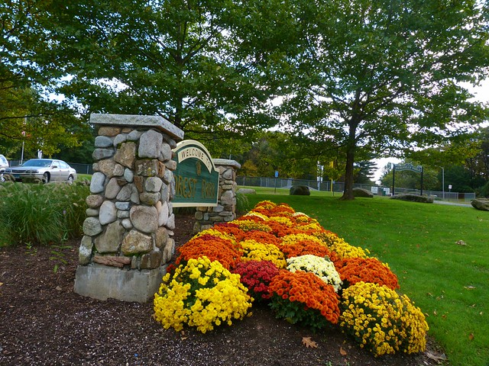

Forest Park

Section 2: Balance Sheets

Section 2 of the Quarterly Financial Report serves as an introduction to the City of Springfield’s balance sheets. These balance sheets are comprised of three components.

Governmental Proprietary Fiduciary

GOVERNMENTAL FUND TYPE

General Fund – The fund used to account for most financial resources and activities governed by the normal town meeting/city council appropriation process.

Stabilization Fund – A fund designed to accumulate amounts for capital and other future spending purposes, although it may be appropriated for any lawful purpose (MGL Ch. 40 §5B). Communities may establish one or more stabilization funds for different purposes and may appropriate into them in any year an amount not to exceed ten percent of the prior year’s tax levy. The total of all stabilization fund balances shall not exceed ten percent of the community’s equalized value, and any interest is added to the fund. A two-thirds vote of town meeting or city council is required to establish, amend the purpose of, or appropriate money into or from the stabilization fund. (See DOR IGR 04-201)

Special Revenue Fund – Funds, established by statute only, containing revenues that are earmarked and restricted to expenditures for specific purposes. Special revenue funds include receipts reserved for appropriation, revolving funds, grants from governmental entities, and gifts from private individuals or organizations.

Covid-19 Fund – Fund type used to account for financial resources used for expenses related to
Covid-19 global flu virus pandemic. This fund is for use by the City of Springfield to vaccinate its citizens and make necessary improvements to battle this pandemic.

Community Preservation Act (CPA) - created by state law (MGL Chapter 44B). It allows cities and towns to adopt a property tax surcharge to help fund projects that preserve the character of the community. Springfield voters adopted the CPA on November 8, 2016 and it went into effect on July 1, 2017.

American Rescue Plan Act (ARPA) - signed into law on March 11, 2021. ARPA is the latest in a series of Coronavirus Disease 2019 (COVID-19)-related relief and economic stimulus legislation.

Capital Project Funds – Fund type used to account for financial resources to be used for the acquisition or construction of major capital facilities (other than those financed by proprietary funds).

PROPRIETARY FUND TYPE

Enterprise Fund – An enterprise fund, authorized by MGL Ch. 44 §53F½, is a separate accounting and financial reporting mechanism for municipal services for which a fee is charged in exchange for goods or services. It allows a community to demonstrate to the public the portion of total costs of a service that is recovered through user charges and the portion that is subsidized by the tax levy, if any. With an enterprise fund, all costs of service delivery--direct, indirect, and capital costs—are identified. This allows the community to recover total service costs through user fees if it chooses. Enterprise accounting also enables communities to reserve the "surplus" or net assets unrestricted generated by the operation of the enterprise rather than closing it out to the general fund at year-end. Services that may be treated as enterprises include, but are not limited to, water, sewer, hospital, trash and airport services. See DOR IGR 08-101

Internal Service Fund – A municipal accounting fund used to accumulate the cost of central services such as data processing, printing, postage, motor pool. Costs or charges to an internal service fund are then allocated to other departments or funds within the government unit.

FIDUCIARY FUND TYPE

Trust Fund – In general, a fund for money donated or transferred to a municipality with specific instructions on its use. As custodian of trust funds, the treasurer invests and expends such funds as stipulated by trust agreements, as directed by the commissioners of trust funds or by town meeting. Both principal and interest may be used if the trust is established as an expendable trust. For nonexpendable trust funds, only interest (not principal) may be expended as directed.

Private-Purpose Trust Funds – A fiduciary trust fund type used to report all trust arrangements, other than those properly reported in pension trust funds or investment trust funds, under which principal and income benefits individuals, private organizations, or other governments. An example is a scholarship fund.

Agency Fund – This is one of four types of fiduciary funds. It is used to report resources in a purely custodial capacity by a governmental unit. Agency funds generally involve only the receipt, temporary investment, and periodic transfer of money to fulfill legal obligations to individuals, private organizations, or other governments. For example, certain employee payroll withholdings typically accumulate in an agency fund until due
In addition, forwarded to the federal government, health care provider, and so forth.

The following information is to define specific line items in the balance sheets to help the user have a clearer understanding of the information presented.

Encumbrance – A reservation of funds to cover obligations arising from purchase orders, contracts, or salary
Commitments that is chargeable to, but not yet paid from,
A specific appropriation account.

Massachusetts General Laws Chapter 656 of the Acts of 1989 - This statute requires the City of Springfield to account for one percent of the prior year’s gross amount to be raised on the tax re-cap as a reservation of fund balance in the general fund.

Net School Spending (NSS) – School budget and municipal budget amounts attributable to education, excluding long-term debt service, student transportation, school lunches and certain other specified school expenditures. A community’s NSS funding must equal or exceed the NSS Requirement established annually by the Department of Elementary and Secondary Education (DESE). (See Education Reform Act of 1993)

Undesignated Fund Balance – Monies in the various government funds as of June 30 that are neither encumbered nor reserved, and are therefore available for expenditure once certified as part of free cash. (See Designated Fund Balance)

Unreserved Fund Balance (Surplus Revenue Account) – The amount by which cash, accounts receivable, and other assets exceed liabilities and restricted reserves. It is akin to a "stockholders’ equity" account on a corporate balance sheet. It is not, however, available for appropriation in full because a portion of the assets listed as "accounts receivable" may be taxes receivable and uncollected. (See Free Cash)

Source: DOR UMAS manual
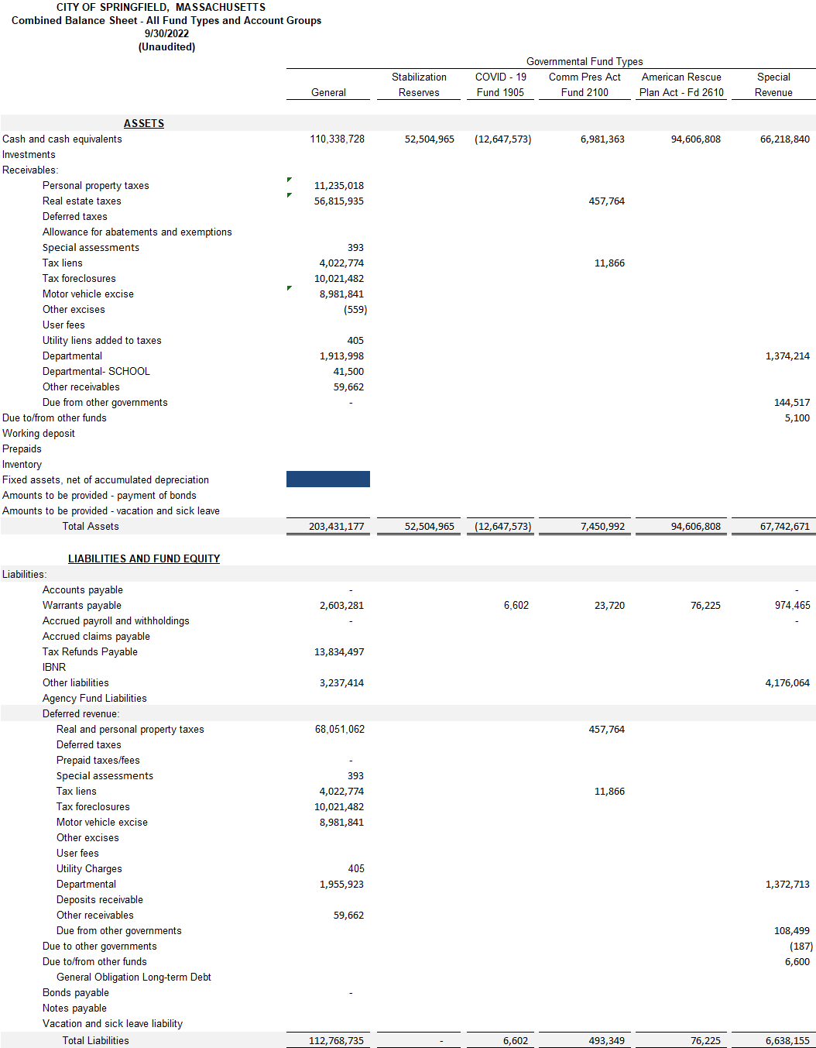
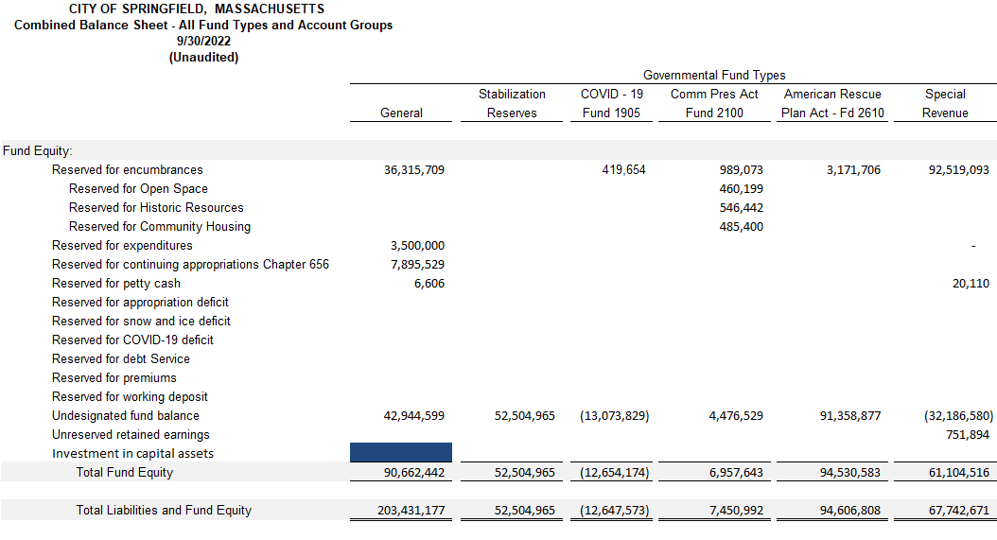

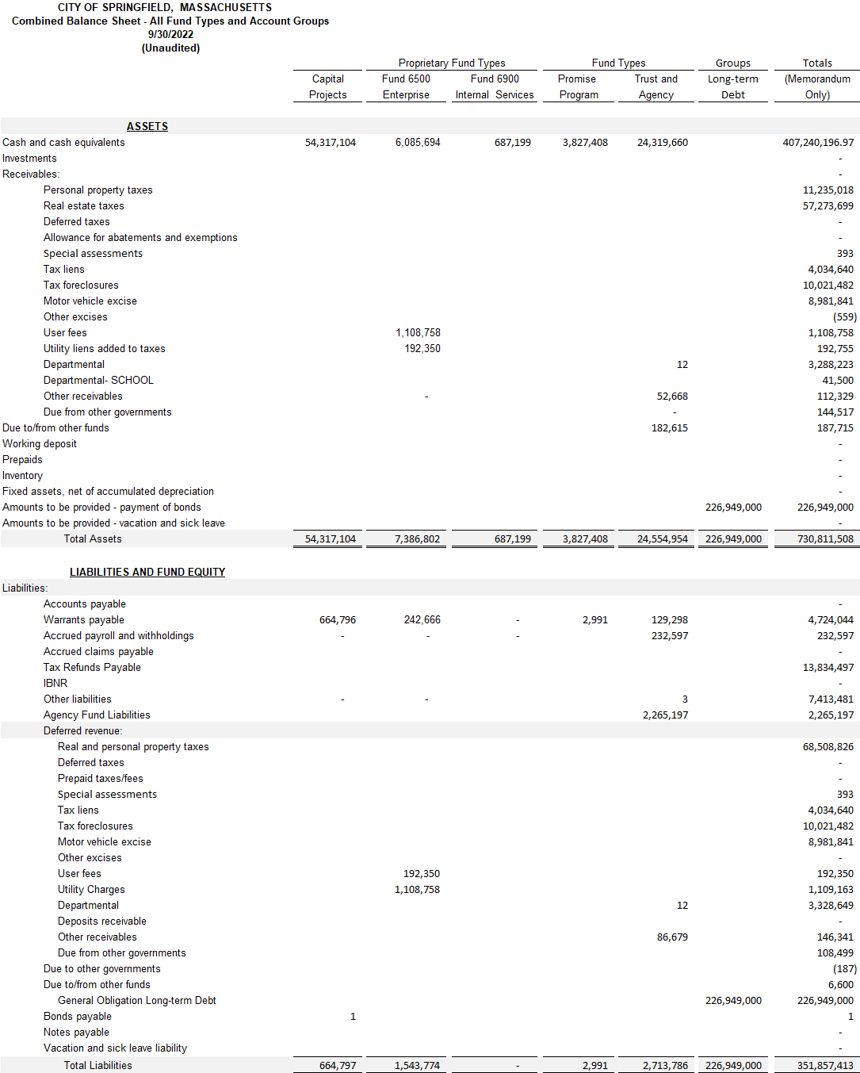
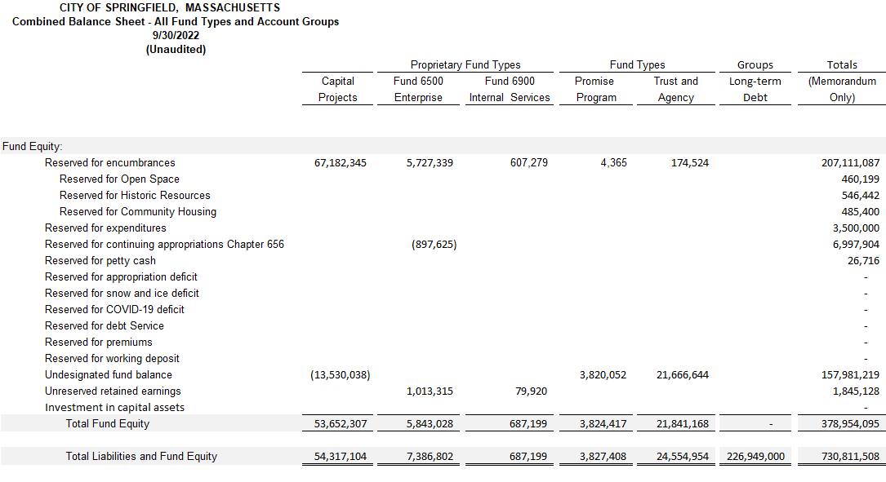

Special Revenue Funds

Special Revenue Funds are used to account for specific revenue sources that are restricted by law or administrative action to expenditures for specific purposes.

Utility/Telephone Fund – This fund accounts for the accumulation of funds used to offset the City’s utility and telephone expenses.

Receipts Reserved Fund – This fund accounts for specific receipts identified by the Commonwealth that are to be held until appropriated.

Community Preservation Fund - This fund has three purposes: the purchase of open space, the preservation
Of historic resources and the establishment of affordable housing.

School Lunch Fund – This fund accounts for the school cafeteria activities and is funded by user fees and grants.

Highway Improvements Fund – This fund is used to account for roadway improvements for which expenditures are reimbursed 100% by the Commonwealth.

Revolving Fund – This fund accounts for self-supporting programs sponsored by the City
.
Federal Grants School Fund – This fund is used to account for grant funds received from the federal
Government, which are designated for specific school, related programs.

Federal Grants City Fund – This fund is used to account for grant funds received from the federal government, which are designated for specific non-school related programs.

State Grants School Fund – This fund is used to account for grant funds received from the Commonwealth, which are designated for specific school related programs.

State Grants City Fund – This fund is used to account for grant funds received from the Commonwealth, which are designated for specific non-school related programs.

Other – This fund accounts for all other legally established special revenues where the funds are spent on governmental purposes.

.

Source: (CAFR) - Comprehensive Annual Financial Report FY2021
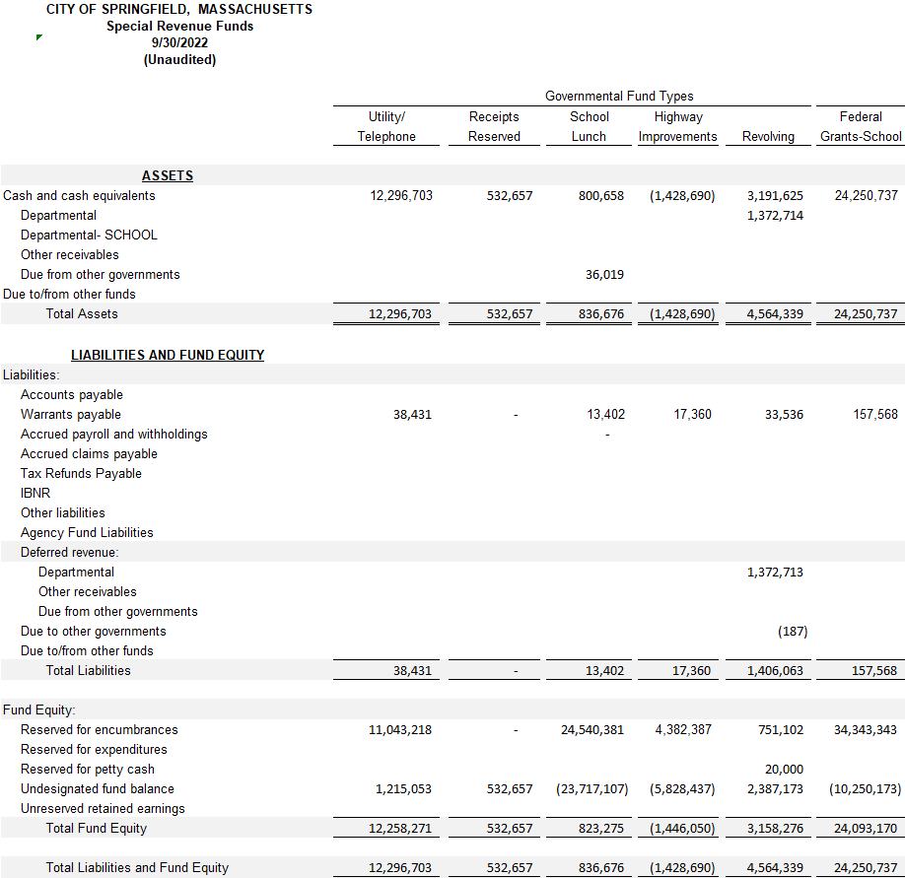

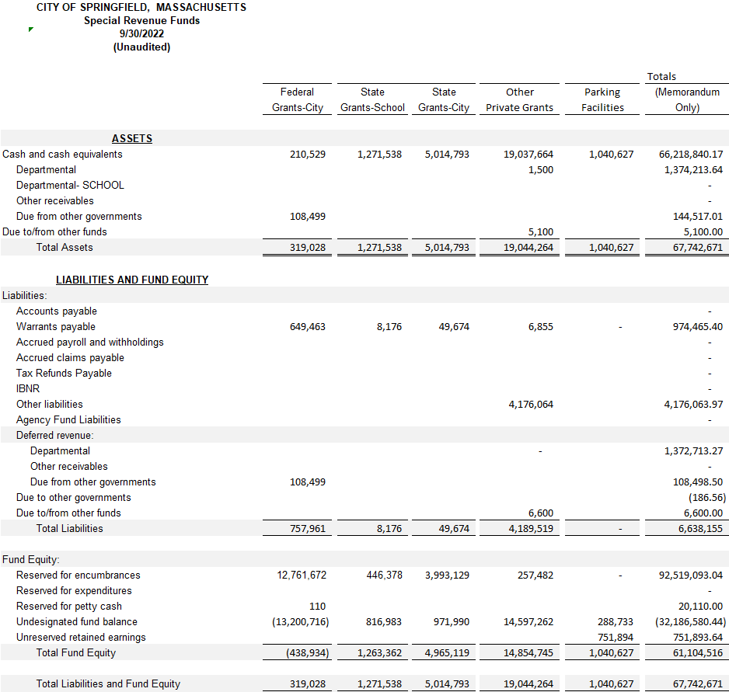

Capital Projects Fund

Capital projects fund are used to account for financial resources to be used for the acquisition, construction or improvement of major capital facilities and equipment (other than those financed by enterprise funds.) Such resources are derived principally from proceeds of general obligation bonds and grants; the capital projects funds are grouped into the following categories:

Public Buildings – used to account for the construction and renovation of various non-school buildings.

Parks – used to account for the acquisition, construction, and improvement of various city owned parks.

Equipment – used to account for the acquisition of capital equipment that is not funded by operating budgets.

Public Works – used to account for roadway, drainage and landfill improvements that are not funded by the
Highway improvements special fund.

Other – This fund accounts for all other legally established capital projects where the funds are spent on
Governmental purposes.

Source: City of Springfield Comprehensive Annual Financial Report FY2018
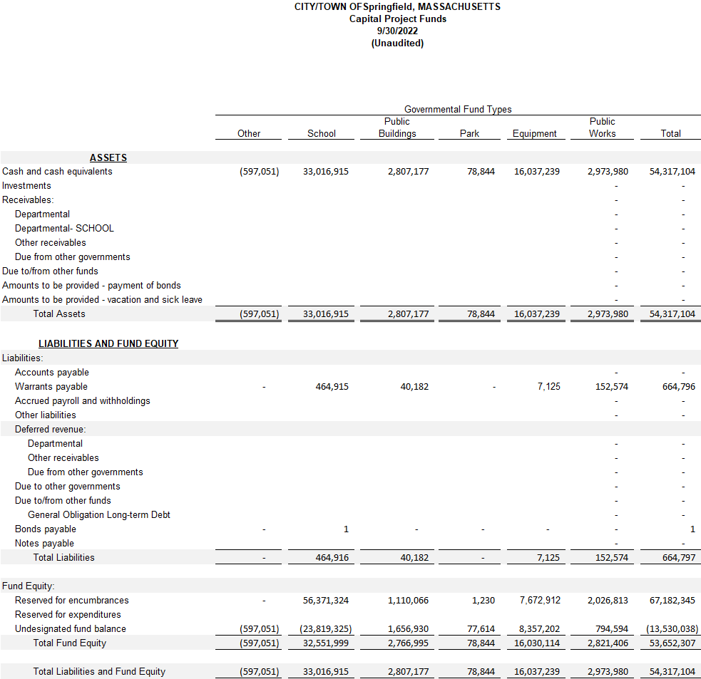

Section 3: Statement of Revenue and Expenditures Section
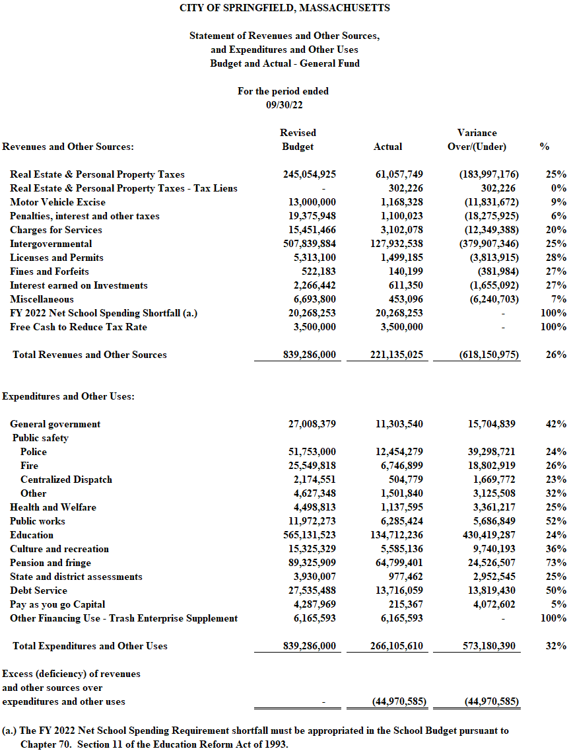

Section 4: Revenue

The City of Springfield receives intergovernmental (State) aid from the state on a quarterly basis.

Real Estate and Personal Property taxes are due on a quarterly basis. Payments are due in August, November, February, and May. The current rate for is $39.04 per $1000 for Commercial and Personal Property is $18.82 per $1000 for Residential Property.

The City issues the major Motor Vehicle Excise bills in the month of February. Bills are issued throughout the fiscal year for those citizens who purchase vehicles.

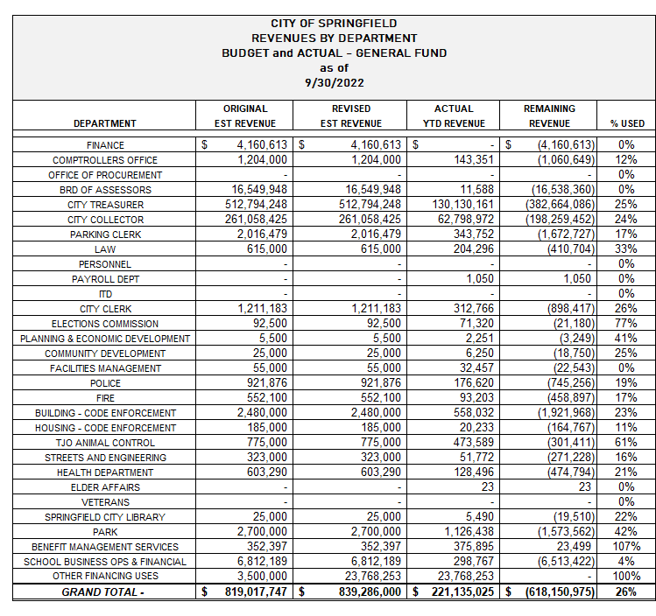

Section 5: Expenditures

The City of Springfield makes a one-time payment to the Springfield Retirement System in July of the fiscal year. The FY 23 total payment was $82.3M. This represents $56.6 for City employees and $25.2 M for School employees and $493k for the Trash Enterprise employees.

All School Teachers' salaries are expended between the months of September-June.

The Park Department runs many seasonal programs occurring in the warmer months of the fiscal year. The Park Department also operates two Municipal Golf Courses, Veterans and Franconia.

The City of Springfield offers Police Officers a yearly career incentive (Quinn Bill). This amount is partially subsidized by the school department for the Springfield support unit.

The City of Springfield supplements the Trash Enterprise fund with a payment from the General Fund operating budget. This supplement is necessary to fully fund the City’s solid waste operation. In FY23
this supplemental payment was $6.2M.

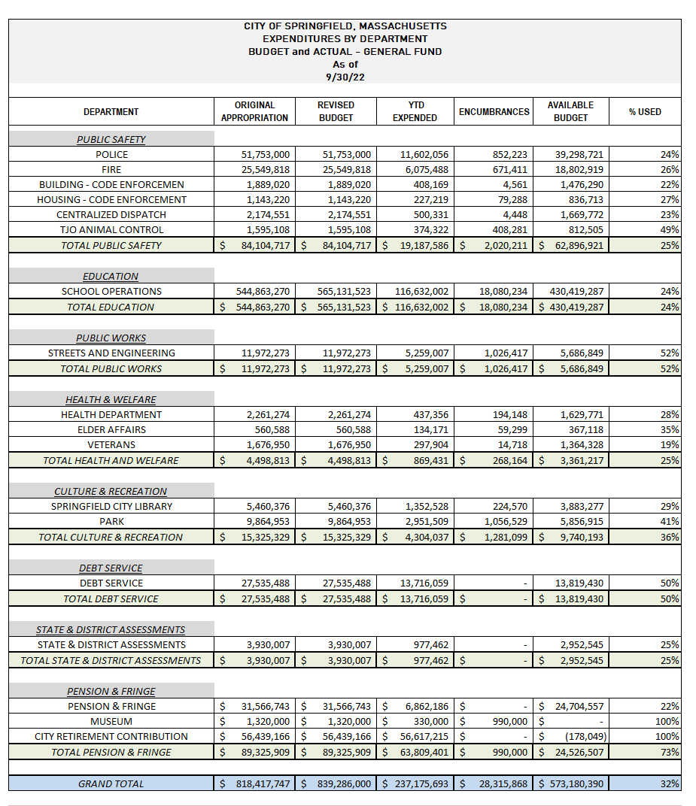
Section 6: Grants / Gifts

The City of Springfield receives roughly $40 million in grant funding each year. This funding enhances programming and services throughout the City. Through the use of grants, Springfield is able to hire personnel, as well as procure professional services, supplies, and equipment that the general fund or taxpayers would otherwise be required to pay for or do without.

Grant Funds Accepted for FY2023 through period ending September 30, 2022: $12,113,175.97

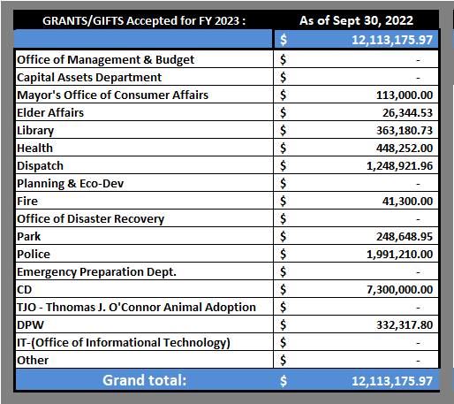

GRANT SUMMARY BY DEPARTMENT:

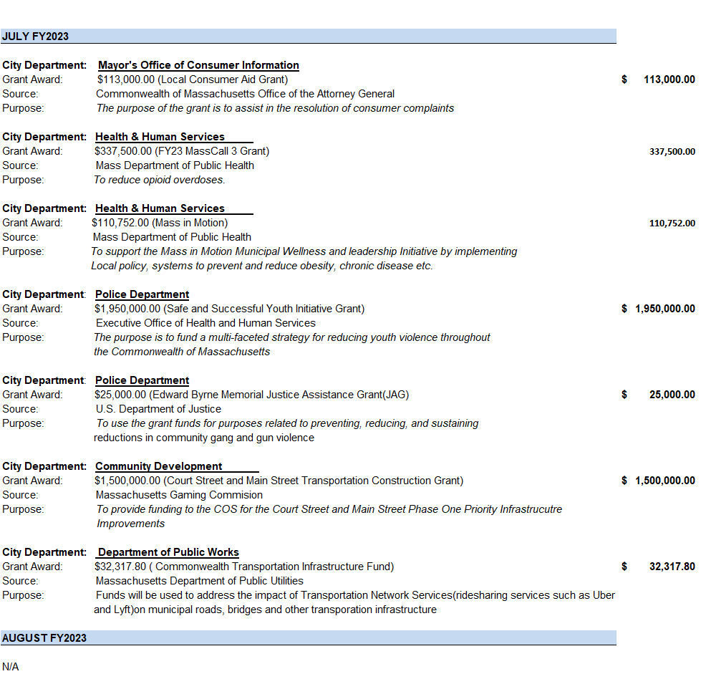

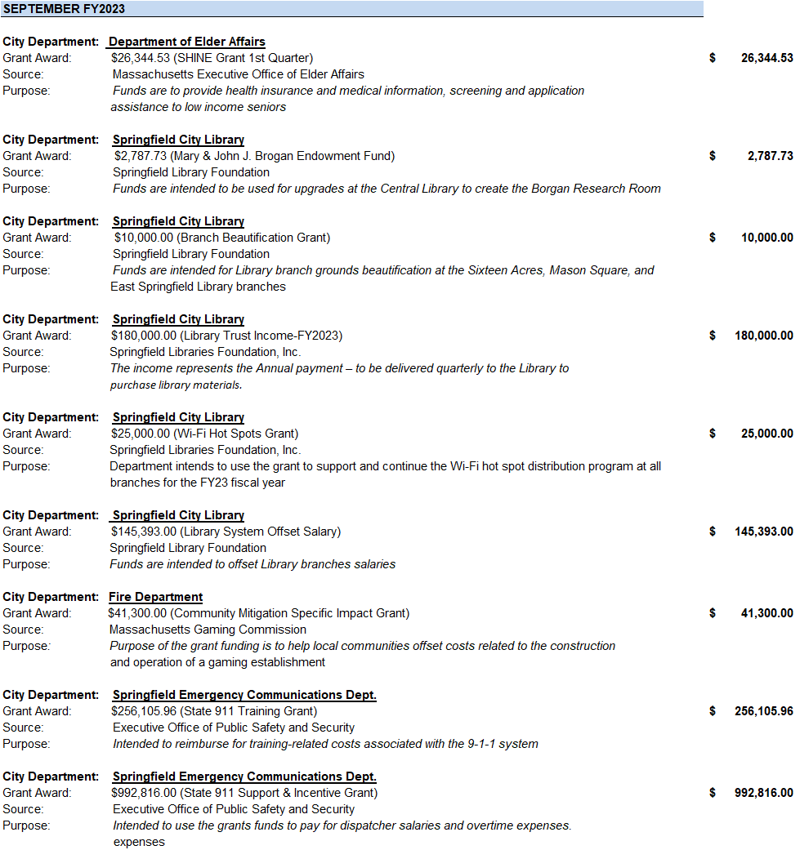
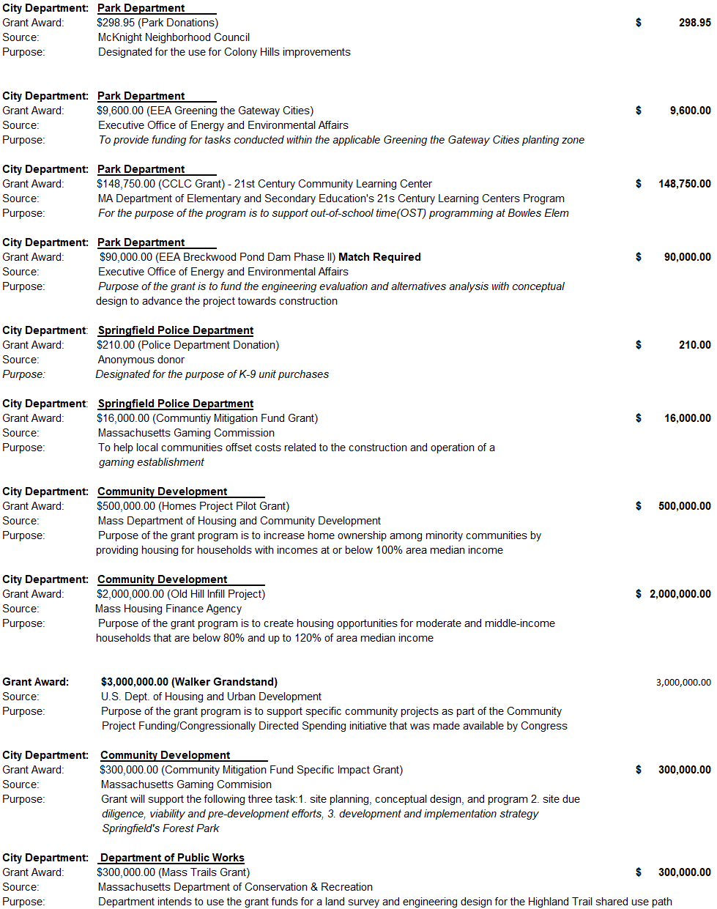

Does not include the Springfield Public Schools (SPS)

