City of Springfield,
Massachusetts



FY12
Quarterly Financial Report

Quarter Ending: September 30, 2011

Presented: November 21, 2011
Table of Contents

- Introduction / Summary……………………………………………………………......3

- Balance Sheets…………………………………………………………………………4

- Revenues……………………………………………………………………………….11

- Expenditures…………………………………………………………………………...14

- Grants…………………………………………………………………………………...18

- Forecast………………………………………………………………………………....21

Section 1: Introduction / Summary

Honorable Members of the City Council:

The following pages represent the Quarterly Financial and Performance report for the City of Springfield examining the period of July 1, 2011 through September 30, 2011 or the first quarter of Fiscal Year 2012 (FY12). Similar to the report prepared and submitted during FY11, the following information is included:

- Balance Sheets
- Revenue Data
- Expenditure Data
- Grants Data
- FY End Forecast Data

Please note that performance data has been omitted from this report due to the elimination of Citistat.

The goal of the report is to be open and transparent about the City’s finances and to educate as many people as possible as to the challenges that the City continues to face. This report is focused on the General Fund budget and does not include the Tornado fund. Please note, this report does not reflect the following:

- Tornado Costs - a separate fund and report has been prepared specifically regarding Tornado costs.
- Snow Storm Costs – estimates have been provided by departments and work is underway; FEMA is developing their preliminary damage assessment to determine if reimbursement will be available.
- Certified Free Cash – documents have been provided to DOR and are currently being reviewed.
- Additional State Aid Allocation – received by the City on 10/31.

If you have any questions about the information in these pages, our team will be available to discuss. Thank you for your attention to this important information.

Respectfully,


Domenic J. Sarno Lee C. Erdmann
Mayor CAFO
SECTION 2: BALANCE SHEETS
Section two of the Quarterly Financial and Performance Report is intended to serve as an introduction to the City of Springfield’s balance sheets. These balance sheets are comprised of three components.

Governmental Proprietary Fiduciary

GOVERNMENTAL FUND TYPE

General Fund – The fund used to account for most financial resources and activities governed by the normal town meeting/city council appropriation process.

Stabilization Fund – A fund designed to accumulate amounts for capital and other future spending purposes, although it may be appropriated for any lawful purpose (MGL Ch. 40 §5B). Communities may establish one or more stabilization funds for different purposes and may appropriate into them in any year an amount not to exceed ten percent of the prior year’s tax levy. The total of all stabilization fund balances shall not exceed ten percent of the community’s equalized value, and any interest shall be added to and become a part of the funds. A two-thirds vote of town meeting or city council is required to establish, amend the purpose of, or appropriate money into or from the stabilization fund. (See DOR IGR 04-201)

Special Revenue Fund – Funds, established by statute only, containing revenues that are earmarked for and restricted to expenditures for specific purposes. Special revenue funds include receipts reserved for appropriation, revolving funds, grants from governmental entities, and gifts from private individuals or organizations.

Capital Projects Fund – Fund type used to account for financial resources to be used for the acquisition or construction of major capital facilities (other than those financed by proprietary funds).
PROPRIETARY FUND TYPE

Enterprise Fund – An enterprise fund, authorized by MGL Ch. 44 §53F½, is a separate accounting and financial reporting mechanism for municipal services for which a fee is charged in exchange for goods or services. It allows a community to demonstrate to the public the portion of total costs of a service that is recovered through user charges
and the portion that is subsidized by the tax levy, if any. With an enterprise fund, all costs of service delivery--direct, indirect, and capital costs—are identified. This allows the community to recover total service costs through user fees if it chooses. Enterprise accounting also enables communities to reserve the "surplus" or net assets unrestricted
generated by the operation of the enterprise rather than closing it out to the general fund at year-end. Services that may be treated as enterprises include, but are not limited to, water, sewer, hospital, and airport services. See DOR IGR 08-101

Internal Service Fund – A municipal accounting fund used to accumulate the cost of central services such as data processing, printing, postage, motor pool. Costs or charges to an internal service fund are then allocated to other departments or funds within the government unit.

FIDUCIARY FUND TYPE

Trust Fund – In general, a fund for money donated or transferred to a municipality with specific instructions on its use. As custodian of trust funds, the treasurer invests and expends such funds as stipulated by trust agreements, as directed by the commissioners of trust funds or by town meeting. Both principal and interest may be used if the trust is established as an expendable trust. For nonexpendable trust funds, only interest (not principal) may be expended as directed.

Private-Purpose Trust Funds – A fiduciary trust fund type used to report all trust arrangements, other than those properly reported in pension trust funds or investment trust funds, under which principal and income benefits individuals, private organizations, or other governments. An example is a scholarship fund.

Agency Fund – This is one of four types of fiduciary funds. It is used to report resources in a purely custodial capacity by a governmental unit. Agency funds generally involve only the receipt, temporary investment, and periodic transfer of money to fulfill legal obligations to individuals, private organizations, or other governments. For example, certain employee payroll withholdings typically accumulate in an agency fund until due
and forwarded to the federal government, health care provider, and so forth.

The following information is to define specific line items in the balance sheets to help the user have a clearer understanding of the information presented.

Encumbrance – A reservation of funds to cover obligations arising from purchase orders, contracts, or salary commitments that is chargeable to, but not yet paid from,
a specific appropriation account.

Massachusetts General Laws Chapter 656 of the Acts of 1989 - This statute requires the City of Springfield to account for one percent of the prior year’s gross amount to be raised on the tax re-cap as a reservation of fund balance in the general fund.

Net School Spending (NSS) – School budget and municipal budget amounts attributable to education, excluding long-term debt service, student transportation, school lunches and certain other specified school expenditures. A community’s NSS funding must equal or exceed the NSS Requirement established annually by the Department of Education (DOE). (See Education Reform Act of 1993)

Undesignated Fund Balance – Monies in the various government funds as of June 30 that are neither encumbered nor reserved, and are therefore available for expenditure once certified as part of free cash. (See Designated Fund Balance)

Unreserved Fund Balance (Surplus Revenue Account) – The amount by which cash, accounts receivable, and other assets exceed liabilities and restricted reserves. It is akin to a "stockholders’ equity" account on a corporate balance sheet. It is not, however, available for appropriation in full because a portion of the assets listed as "accounts receivable" may be taxes receivable and uncollected. (See Free Cash)
Source: DOR UMAS manual

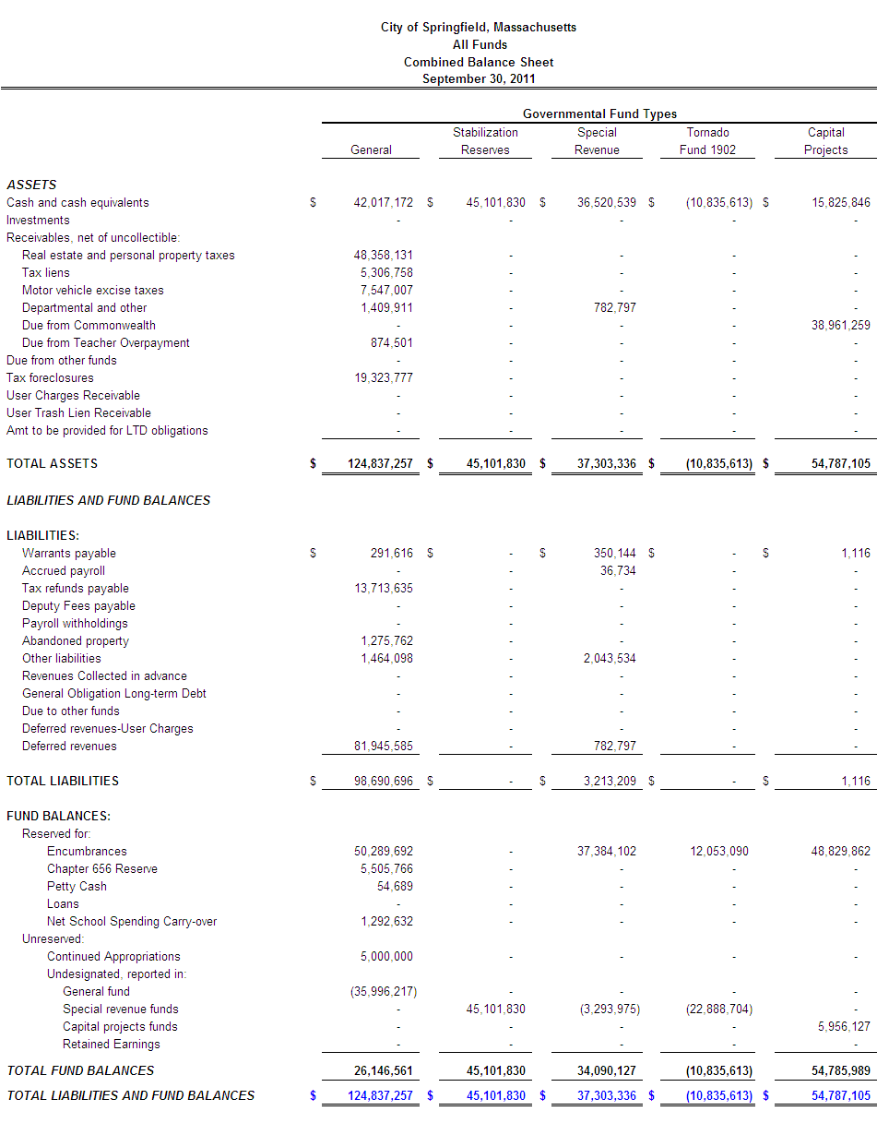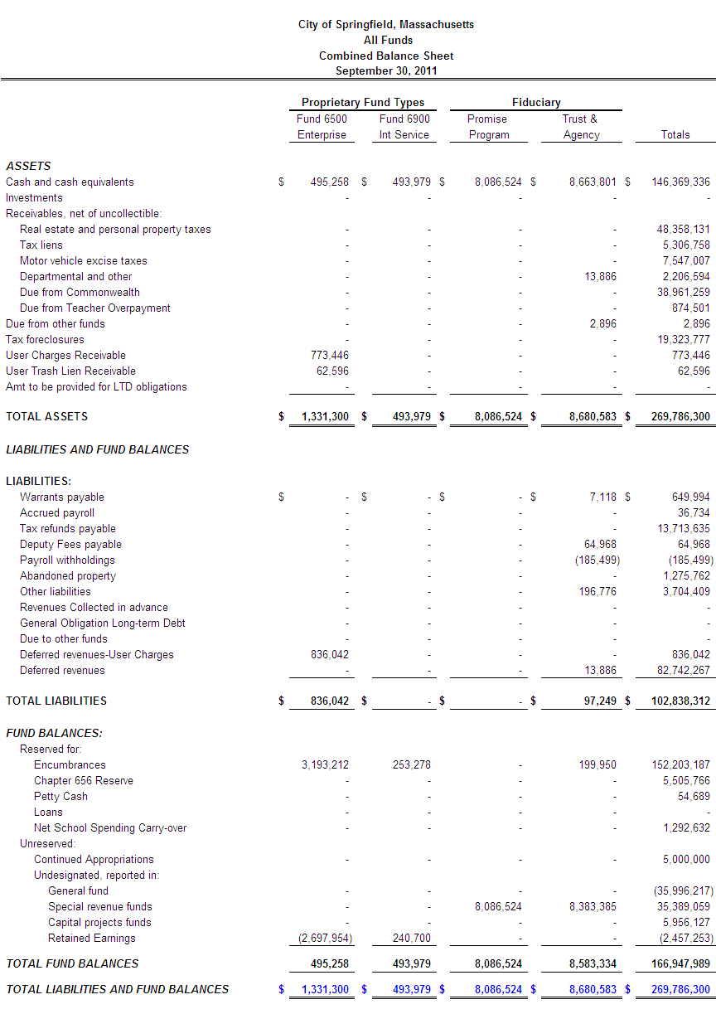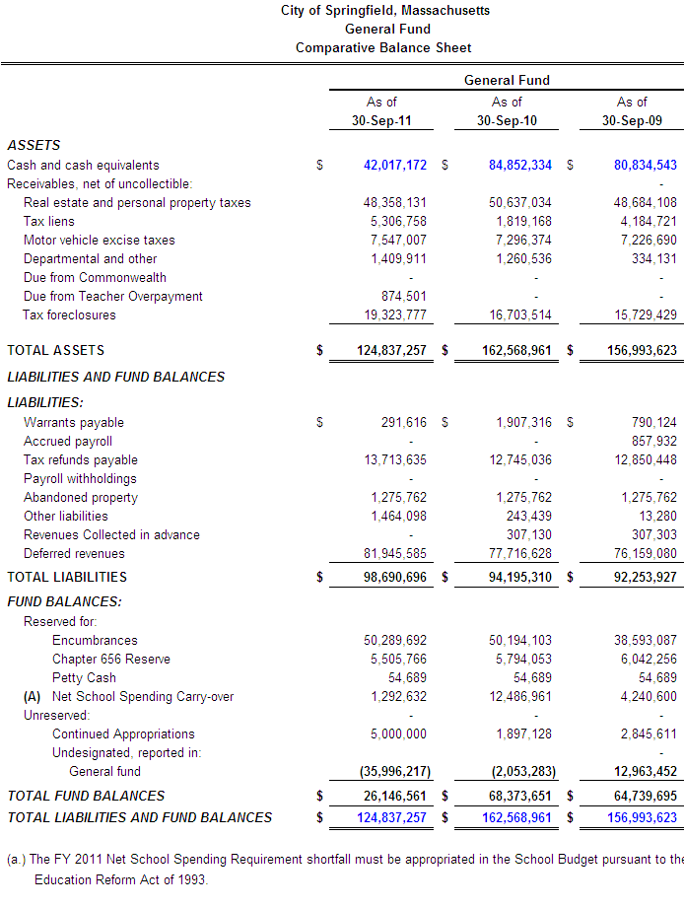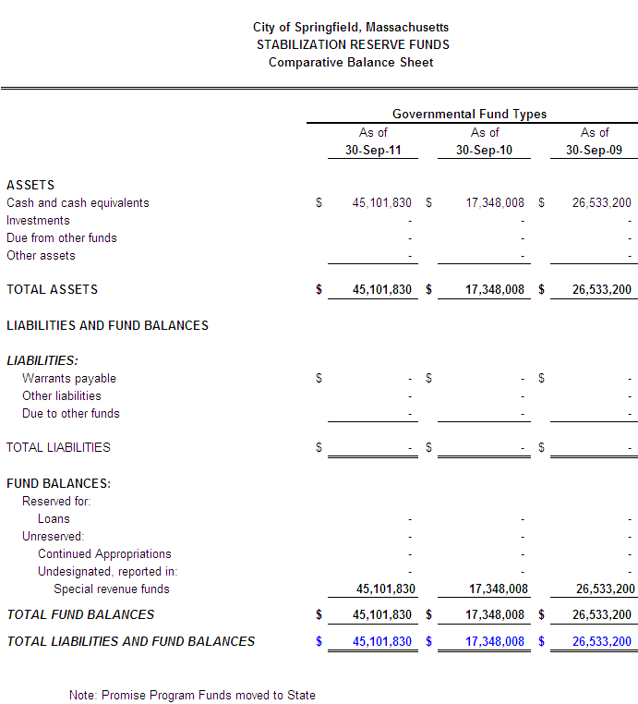

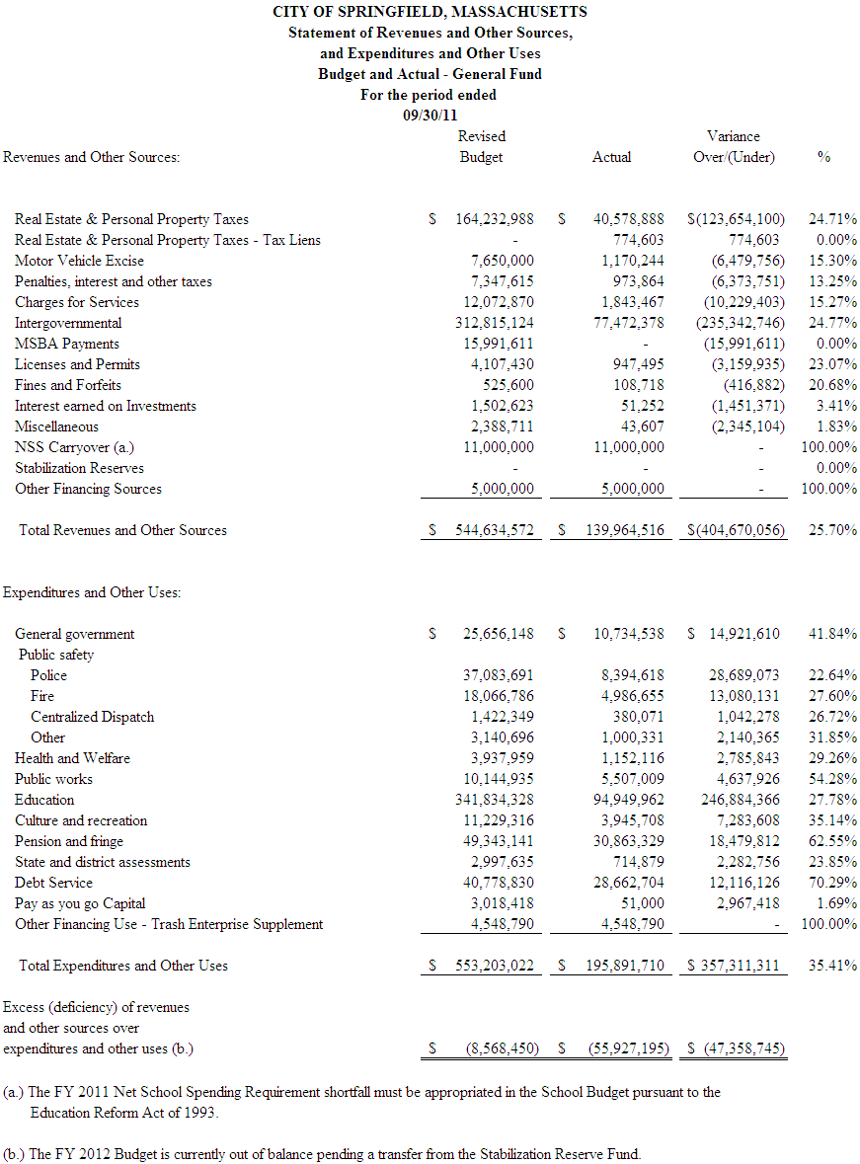
Section 3: Revenues Highlights
The City of Springfield receives intergovernmental aid from the state on a quarterly basis

Real Estate and Personnel Property taxes are due on a quarterly basis. Payments are due in August, November, February, and May

The City issues the major Motor Vehicle Excise bills in the month of March. Bills are issued throughout the fiscal year for those citizens who purchase vehicles.

The FY 2011 Net School Spending Requirement shortfall must be appropriated in the School Budget pursuant to the Education Reform Act of 1993.

MSBA payments are reimbursements received from the state for approved school construction projects.

Below is a detailed listing of items added to the FY 2012 Adopted Budget:

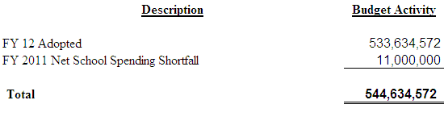
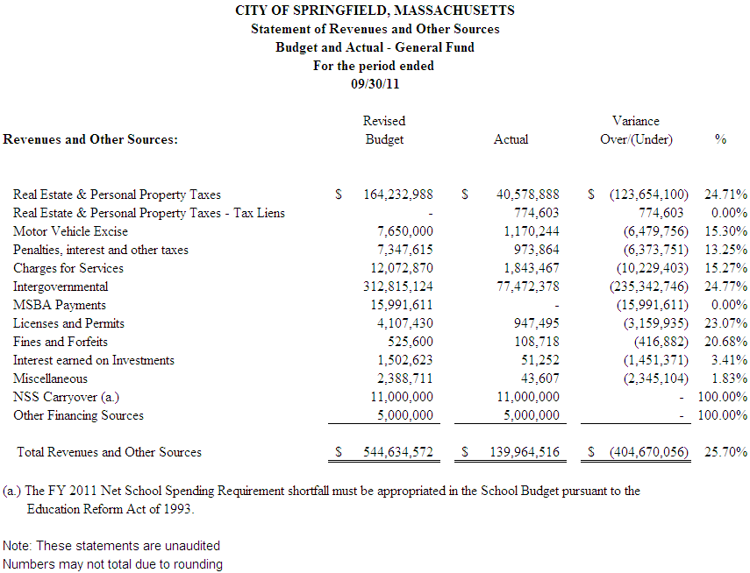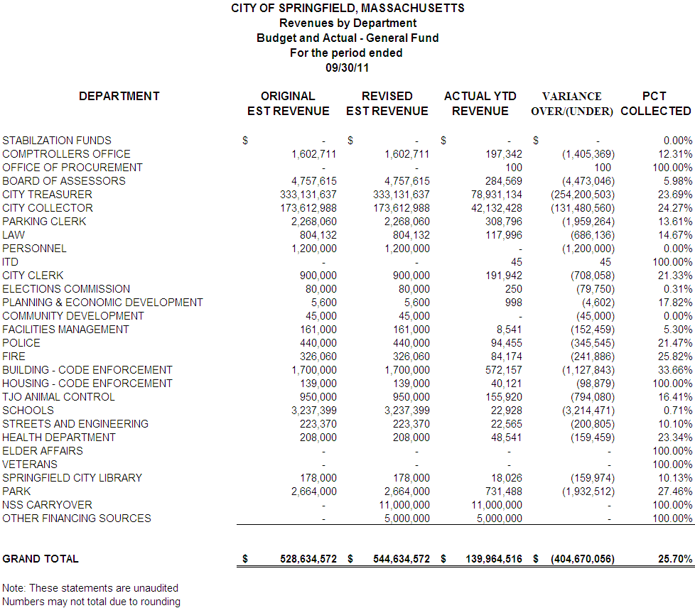
Section 4: Expenditures Highlights
The City of Springfield makes a one-time payment to the Retirement System in July of the fiscal year. The FY 12 payment was $24M

All School Teachers' salaries are expended between the months of September-June.

The Park Department runs many seasonal programs occurring in the warmer months of the fiscal year. The Park Department also operates two Municipal Golf Courses, Veterans and Franconia.

The Department of Public Works (DPW) experiences higher expenditures in the winter months due to the need for Snow and Ice Removal.

The City of Springfield offers Police Officers a yearly career incentive (Quinn Bill). The City will make this payment in November.

The City of Springfield has established a Utility Revolving Fund. Department’s telephone and electric budgets are expended in the General Fund and moved to the Revolving Fund. This fund allows the City to pay telephone and electric bills in a central location.

The City of Springfield builds a lost time projection into the General Fund operating budget. The projected lost time in the FY 11 operating budget is $800K and this is found in the City Comptroller's budget.

The City of Springfield supplements the Trash Enterprise fund with a payment from the General Fund operating budget. This supplement is necessary to fully fund the City’s solid waste operation. In FY 12 this supplement will be made in October.

$45.5M has been encumbered in the current budget by the City to cover obligations arising from purchase orders and contracts; that are chargeable to a department’s budget but not yet paid from a specific appropriation account.

The City expended $28.6M of the Long Term Debt budget in the month of September.

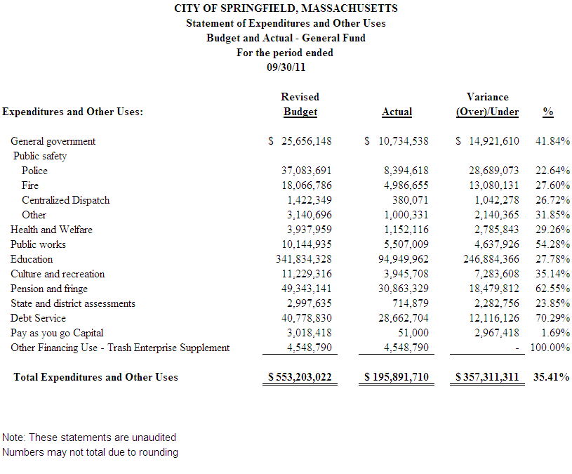
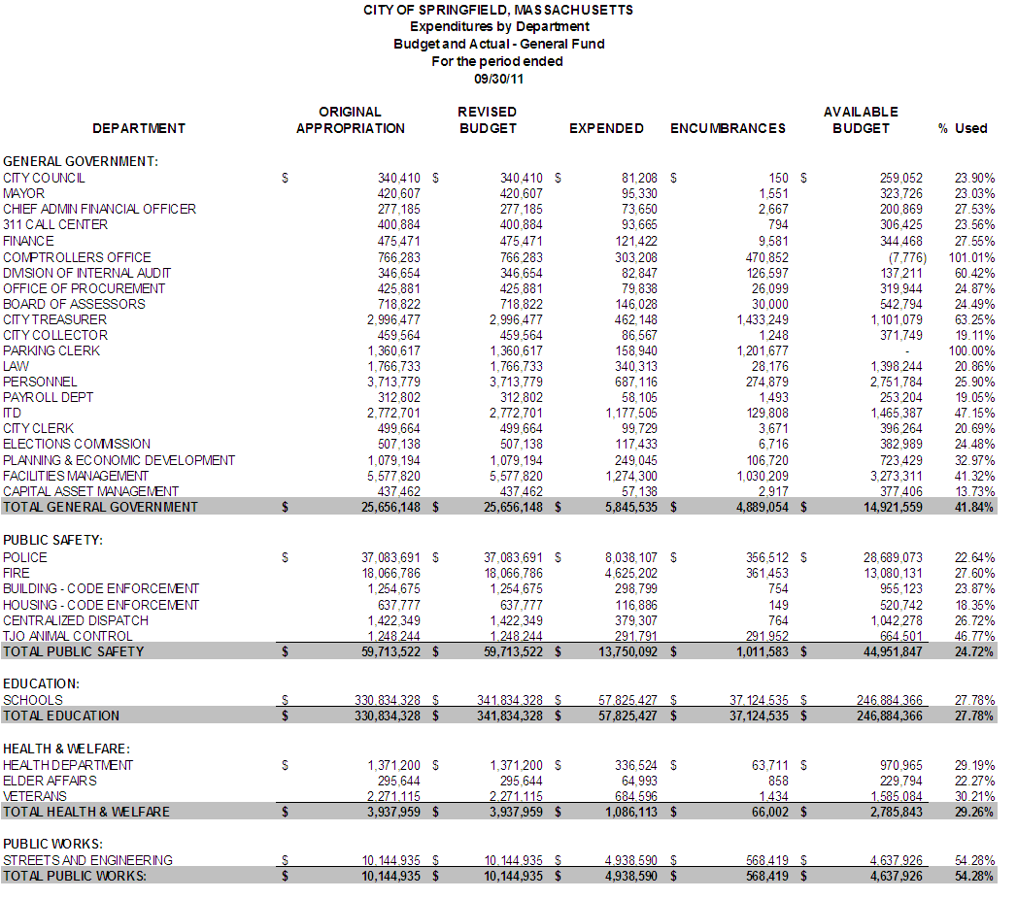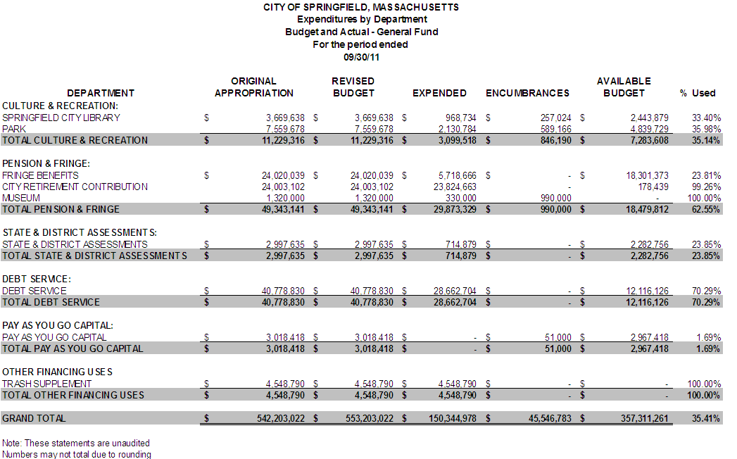
SECTION 5: GRANTS / GIFTS
The City of Springfield receives roughly $16.9 million in grant funding each year. This funding enhances programming and services throughout the City. Through the use of grants, Springfield is able to hire personnel, as well as procure professional services, supplies, and equipment that the general fund or taxpayers would otherwise be required to pay for or do without.

Grant Funds Accepted for this Financial Reporting Period: $3,126,354

City Department: Animal Control
Grant Award: $12,000
Source: Massachusetts Animal Coalition
Purpose: To spay and neuter animals.

City Department: Elder Affairs
Grant Award: $56,057
Source: Massachusetts Executive Office of Elder Affairs
Purpose: Provide information, screening, and application assistance to low-income seniors with regards to medications, Medicare Drug Plans, and other medical assistance programs.

City Department: Health
Grant Award: $25,000
Source: Pioneer Valley Area Health Education Center
Purpose: To provide an academic summer enrichment program focusing on preparation for careers in oral and public health.

City Department: Library
Grant Award: $31,335
From: Regional Employment Board
Purpose: To teach staff for the Read/Write Now Adult Learning Center.

City Department: Library
Grant Award: $134,413
Source: Springfield Library Foundation
Purpose: To assist with the operating expenses for the Mason Square Library Branch.

City Department: Health
Grant Award: $32,038
Source: Pioneer Valley Area Health Education Center
Purpose: To provide an academic summer enrichment program focusing on preparation for careers in oral and public health.

City Department: Elder Affairs
Grant Award: $677,148
Source: Senior Service America
Purpose: Enroll eligible persons into the Senior AIDES Program during the program period, assigning them to part-time community service positions, and transitioning a portion of such persons to unsubsidized employment during the program year.

City Department: Housing Department
Grant Award: $1,165,330
Source: U.S. Housing and Urban Development
Purpose: To provide homeless assistance in an effort to prevent and end homelessness.

City Department: Library
Grant Award: $12,500
Source: Massachusetts Board of Library Commissioners
Purpose: For the Library's Conversation Circles Program, which provides adults speech practice and library resource orientation, developing their early literacy skills.

City Department: Library
Grant Award: $7,000
Source: Massachusetts Department of Early Education
Purpose: Provide outreach, child/family programming, professional development, materials and hold family-oriented literacy events.

City Department: Library
Grant Award: $10,492
Source: Irene and George Davis Foundation
Purpose: To provide space; curriculum design; select and order children's books; reproduce materials; implement training; and prepare handouts.

City Department: Library
Grant Award: $181,571
Source: Massachusetts Department of Elementary and Secondary Education
Purpose: Provide staffing, training, supplies, equipment, as well as workshops to assist learners and their families meet their literacy goals.

City Department: Health
Grant Award: $5,000
Source: Irene E & George A Davis Foundation
Purpose: To fund open gym programming.

City Department: Health
Grant Award: $30,000
Source: Health Resources in Action
Purpose: To continue the change work the Department has been engaged in to support healthier eating and active living.

City Department: Health
Grant Award: $90,000
Source: Massachusetts Department of Public Health, Bureau of Substance Abuse Services
Purpose: To pay for prevention programming related to opioid.

City Department: Police
Grant Award: $207,195
Source: U.S. Department of Justice
Purpose: For equipment and technology upgrades and replacement for priority areas in the delivery of modern police services.

City Department: Elder Affairs
Grant Award: $149,275
Source: Massachusetts Executive Office of Elder Affairs
Purpose: To support Council on Aging activities within the City.

City Department: Parks
Grant Award: $300,000
From: Massachusetts Department of Elementary and Secondary Education
Purpose: To fund the City’s afterschool programming.

Section 6: Forecast
The forecast looks at the two major aspects of the annual operating budget:

- Revenue – The revenue forecast shows the FY09, FY10 and FY11 actual collections along with what was budgeted for FY12. In addition, it shows a projection for the FY12 year-end based on year to date collections and known collection cycles for the remainder of the fiscal year.
- Spending – The spending forecast shows the FY09, FY10 and FY11 actual spending by department along with what was budgeted for spending for FY12. In addition, it shows a projection for the FY12 year-end based on year to date spending and knowledge and trends of the department.
- The forecast is subject to change throughout the fiscal year and does not represent a definite surplus or deficiency.

Revenue Projection:
For the first quarter of FY12 (July 2011 through September 2011) revenue collections appear to be on track with budgeted amounts. All revenue collections will be monitored monthly during the remainder of the fiscal year. Specific items will be carefully monitored to ensure they are meeting budgeted amounts including:

- Stabilization Transfer – The budget as adopted by the City Council on June 22, 2011 requires additional revenue to be balanced. The revenue needed is $8.9 million based on the following calculation:

The year-end forecast assumes that a resolution to balance the budget will be agreed upon by the Mayor and Council and adopted before the FY12 tax rate is set.

- Unrestricted General Government Aid – As part of the State’s FY11 year-end surplus, they have committed to restoring State Aid to FY11 levels. This totals a restoration of $2.3 million to Springfield that will be paid in October of 2011. This additional State Aid is not currently accounted for in the year-end projection. It may be considered to offset the transfer needed from Stabilization to balance the FY12 budget, to address some of the “watch” items reflected in this report, or transferred to Stabilization to add to the fund’s balance.

- Tax Collections – The tax revenue assumed for the FY12 budget was based on a projection pre-DOR certification and pre-tornado. It is expected that final valuations will vary from the budgeted amount. At this time, the Assessors have not provided a value to this change and will do so once DOR certifies values.

- Departmental Revenue – Although some departmental revenue projections are adjusted to reflect the seasonality of collections, others may have exposures that will need to be watched and addressed if collections do not increase. Specifically, On-Street Parking revenue collections to date do not appear as though they will reach the projected collections at year end.

Spending Projection:
For the first quarter of FY12 (July 2011 through September 2011) it is premature to project specific programmatic surpluses and deficiencies, however the exercise of completing a projection does help to identify certain budgeted areas to watch for exposures. Spending by department and category will continue to be monitored monthly and the year-end projection will be refined for the next quarter report.

Specific items will be carefully monitored to identify potential exposures and solutions for addressing the needs. If exposures result in an actual deficiency, City Council action will be needed to address them. Spending to be watched for exposures include:

- Law – Settlements – In the last 2 years, around $435K has been spent on settlements. FY12 budgeted $195,500 which could result in an exposure of $240K.

- Treasurer – Professional Services – In the last 2 years, an average of $1.47 million has been budgeted for the tax title program which generates revenue for the City. The FY 12 budget appropriates $1.1 million which could result in an exposure.

- Fire – Overtime and OTPS – For the FY12 budget, a significant reduction to overtime was taken along with a vacancy savings amount. To date, overtime is tracking high (to accommodate the summer seasonality of their spending) and the department has no vacant positions. The Fire department is considering options that will impact current operations. In addition, OTPS reductions are difficult to sustain due to contracted replacements of turnout gear for firefighters.

- Veterans’ – Caseload – During FY11, the Veterans benefits caseload significantly increased in comparison to prior years. The FY12 budget reflects that caseload will remain at increased levels, however only time will tell if the appropriation will be sufficient to cover the mandated costs.

- Public Works – Snow & Ice – The FY12 budget appropriates $1.5 million for snow and ice operations. In FY11, deficit spending authorization and supplemental funding was needed. In FY10, however, this account experienced a surplus. The exposure to this funding will only be known as the winter season progresses.

Does not include the Springfield Public Schools (SPS) which receives an estimated $68.6M in grant funding annually. The City’s Grants Director has written/submitted three grants for the SPS and continues to work with its staff when asked.

