City of Springfield,
Massachusetts



FY12
Quarterly Financial Report

Quarter Ending: December 31, 2011

Presented: February 13, 2012
Table of Contents

- Introduction / Summary……………………………………………………………......3

- Balance Sheets…………………………………………………………………………4

- Revenues……………………………………………………………………………….11

- Expenditures…………………………………………………………………………...14

- Grants…………………………………………………………………………………...18

- Forecast………………………………………………………………………………....20

Section 1: Introduction / Summary

Honorable Members of the City Council:

The following pages represent the Quarterly Financial Report for the City of Springfield examining the period of October 1, 2011 through December 31, 2011 or the second quarter of Fiscal Year 2012 (FY12). The following information is included:

- Balance Sheets
- Revenue Data
- Expenditure Data
- Grants Data
- FY End Forecast Data

Please note that performance data has been omitted from this report due to the elimination of the Citistat Department.

The goal of the report is to be open and transparent about the City’s finances and to educate as many people as possible as to the challenges that the City continues to face. This report is focused on the General Fund budget and does not include the Tornado fund or the October Snow Storm Fund. Please note, this report does not reflect the following:

- Tornado Costs - a separate fund and report has been prepared specifically regarding Tornado costs (a tornado fund summary is included in this report).
- Snow Storm Costs – a separate fund and report has been prepared specifically regarding Snow Storm costs (an October snow storm fund summary is included in this report).

Although we are currently projecting both revenue and expenditure deficits our goal is to monitor and manage the FY12 budget in order to add sufficient funds to the stabilization reserve so that the fund equals $40 million later this fiscal year. We are:
- Refilling only the most critical vacancies.
- Closely monitoring revenues.
- Authorizing only the most critical OTPS and capital expenditures.

If you have any questions about the information in these pages, our team will be available to discuss. Thank you for your attention to this important information.

Respectfully,


Domenic J. Sarno Lee C. Erdmann
Mayor CAFO
SECTION 2: BALANCE SHEETS
Section two of the Quarterly Financial Report is intended to serve as an introduction to the City of Springfield’s balance sheets. These balance sheets are comprised of three components.

Governmental Proprietary Fiduciary

GOVERNMENTAL FUND TYPE

General Fund – The fund used to account for most financial resources and activities governed by the normal town meeting/city council appropriation process.

Stabilization Fund – A fund designed to accumulate amounts for capital and other future spending purposes, although it may be appropriated for any lawful purpose (MGL Ch. 40 §5B). Communities may establish one or more stabilization funds for different purposes and may appropriate into them in any year an amount not to exceed ten percent of the prior year’s tax levy. The total of all stabilization fund balances shall not exceed ten percent of the community’s equalized value, and any interest shall be added to and become a part of the funds. A two-thirds vote of town meeting or city council is required to establish, amend the purpose of, or appropriate money into or from the stabilization fund. (See DOR IGR 04-201)

Special Revenue Fund – Funds, established by statute only, containing revenues that are earmarked for and restricted to expenditures for specific purposes. Special revenue funds include receipts reserved for appropriation, revolving funds, grants from governmental entities, and gifts from private individuals or organizations.

Capital Projects Fund – Fund type used to account for financial resources to be used for the acquisition or construction of major capital facilities (other than those financed by proprietary funds).
PROPRIETARY FUND TYPE

Enterprise Fund – An enterprise fund, authorized by MGL Ch. 44 §53F½, is a separate accounting and financial reporting mechanism for municipal services for which a fee is charged in exchange for goods or services. It allows a community to demonstrate to the public the portion of total costs of a service that is recovered through user charges
and the portion that is subsidized by the tax levy, if any. With an enterprise fund, all costs of service delivery--direct, indirect, and capital costs—are identified. This allows the community to recover total service costs through user fees if it chooses. Enterprise accounting also enables communities to reserve the "surplus" or net assets unrestricted
generated by the operation of the enterprise rather than closing it out to the general fund at year-end. Services that may be treated as enterprises include, but are not limited to, water, sewer, hospital, and airport services. See DOR IGR 08-101

Internal Service Fund – A municipal accounting fund used to accumulate the cost of central services such as data processing, printing, postage, motor pool. Costs or charges to an internal service fund are then allocated to other departments or funds within the government unit.

FIDUCIARY FUND TYPE

Trust Fund – In general, a fund for money donated or transferred to a municipality with specific instructions on its use. As custodian of trust funds, the treasurer invests and expends such funds as stipulated by trust agreements, as directed by the commissioners of trust funds or by town meeting. Both principal and interest may be used if the trust is established as an expendable trust. For nonexpendable trust funds, only interest (not principal) may be expended as directed.

Private-Purpose Trust Funds – A fiduciary trust fund type used to report all trust arrangements, other than those properly reported in pension trust funds or investment trust funds, under which principal and income benefits individuals, private organizations, or other governments. An example is a scholarship fund.

Agency Fund – This is one of four types of fiduciary funds. It is used to report resources in a purely custodial capacity by a governmental unit. Agency funds generally involve only the receipt, temporary investment, and periodic transfer of money to fulfill legal obligations to individuals, private organizations, or other governments. For example, certain employee payroll withholdings typically accumulate in an agency fund until due
and forwarded to the federal government, health care provider, and so forth.

The following information is to define specific line items in the balance sheets to help the user have a clearer understanding of the information presented.

Encumbrance – A reservation of funds to cover obligations arising from purchase orders, contracts, or salary commitments that is chargeable to, but not yet paid from,
a specific appropriation account.

Massachusetts General Laws Chapter 656 of the Acts of 1989 - This statute requires the City of Springfield to account for one percent of the prior year’s gross amount to be raised on the tax re-cap as a reservation of fund balance in the general fund.

Net School Spending (NSS) – School budget and municipal budget amounts attributable to education, excluding long-term debt service, student transportation, school lunches and certain other specified school expenditures. A community’s NSS funding must equal or exceed the NSS Requirement established annually by the Department of Elementary and Secondary Education (DESE). (See Education Reform Act of 1993)

Undesignated Fund Balance – Monies in the various government funds as of June 30 that are neither encumbered nor reserved, and are therefore available for expenditure once certified as part of free cash. (See Designated Fund Balance)

Unreserved Fund Balance (Surplus Revenue Account) – The amount by which cash, accounts receivable, and other assets exceed liabilities and restricted reserves. It is akin to a "stockholders’ equity" account on a corporate balance sheet. It is not, however, available for appropriation in full because a portion of the assets listed as "accounts receivable" may be taxes receivable and uncollected. (See Free Cash)
Source: DOR UMAS manual

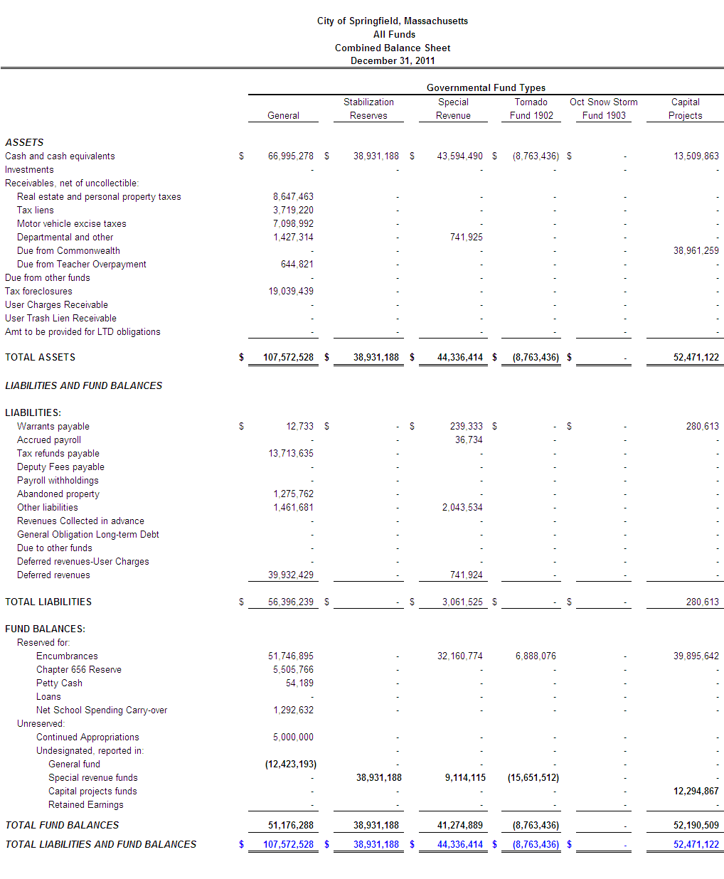

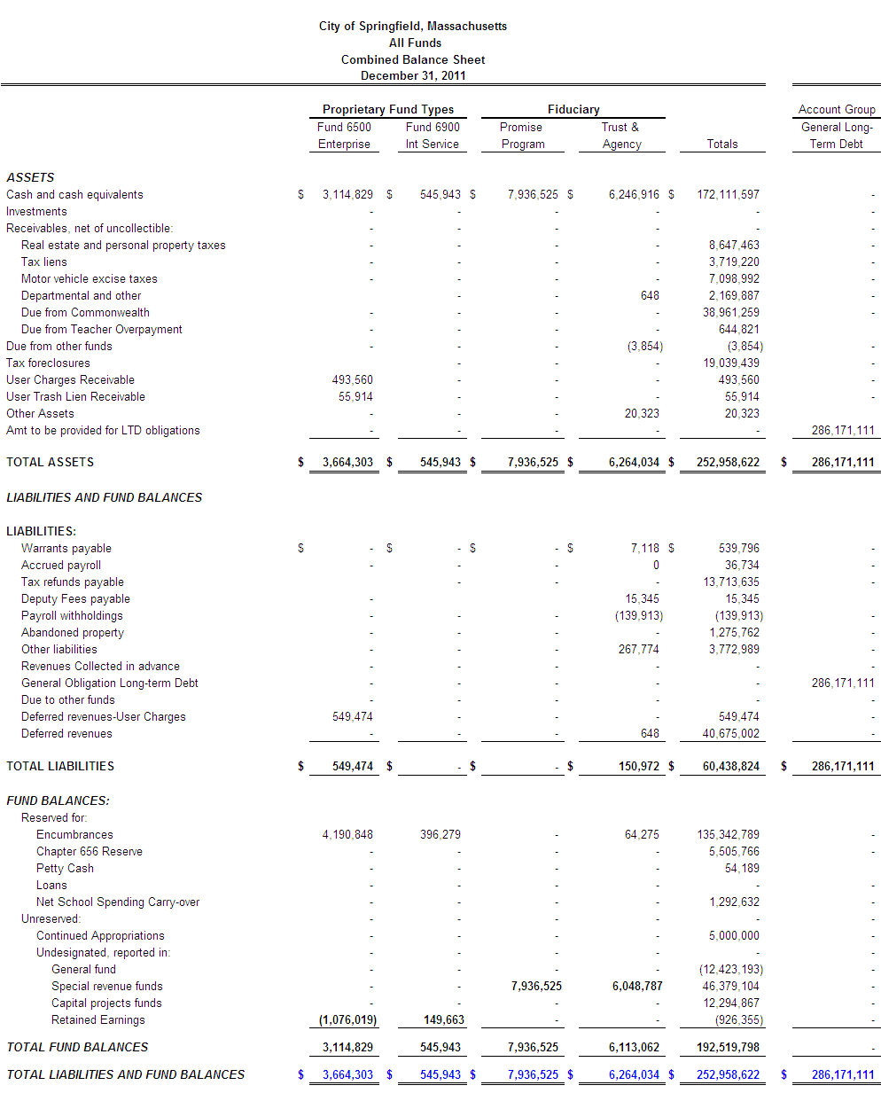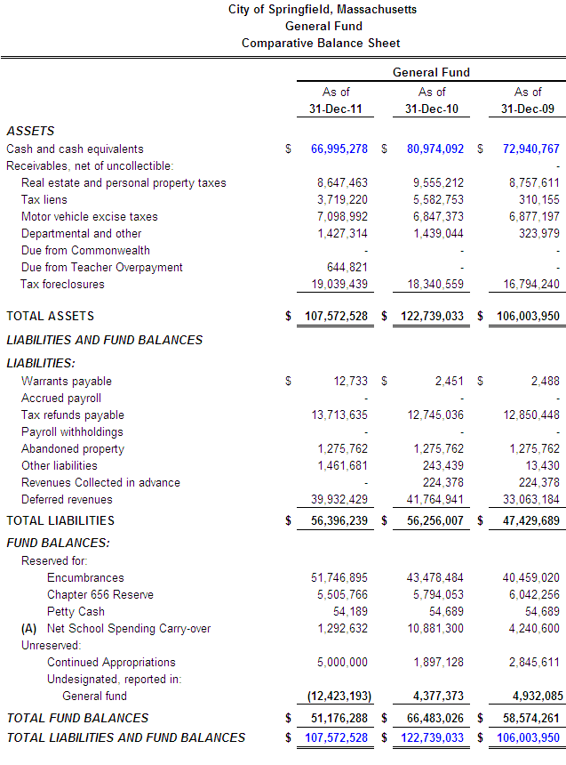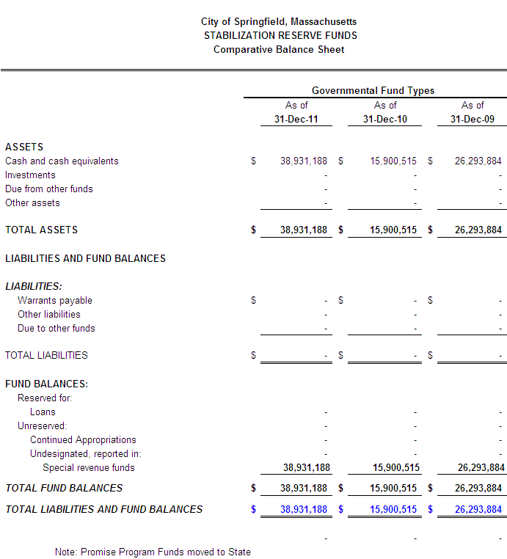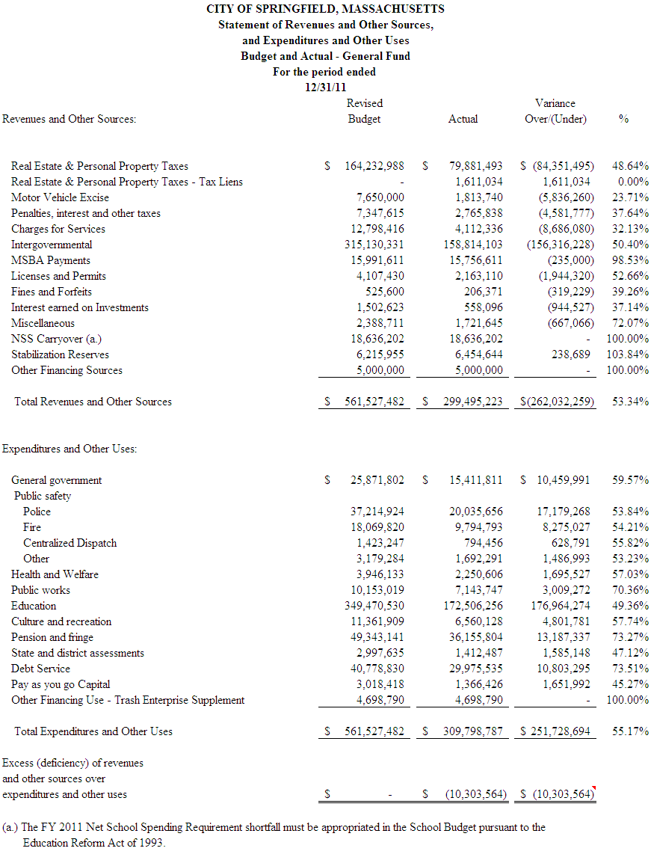

Section 3: Revenues Highlights
The City of Springfield receives intergovernmental aid from the state on a quarterly basis

Real Estate and Personnel Property taxes are due on a quarterly basis. Payments are due in August, November, February, and May

The City issues the major Motor Vehicle Excise bills in the month of March. Bills are issued throughout the fiscal year for those citizens who purchase vehicles.

The City has been reimbursed for all prior grant school construction projects

The FY 2011 Net School Spending Requirement shortfall must be appropriated in the School Budget pursuant to the Education Reform Act of 1993.

MSBA payments are reimbursements received from the state for approved school construction projects.

Below is a detailed listing of items added to the FY 2012 Adopted Budget:

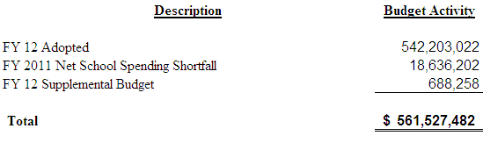

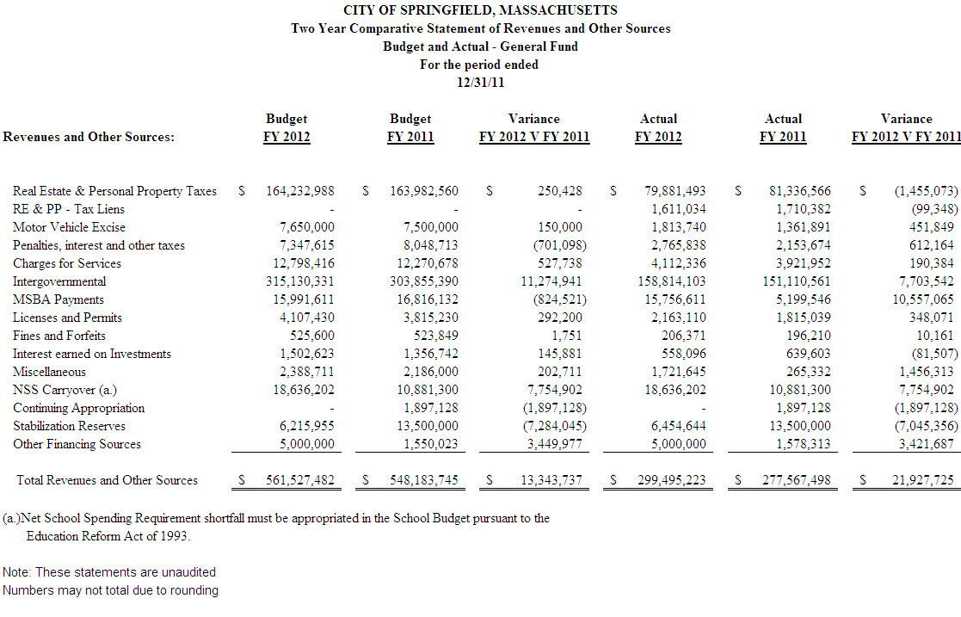
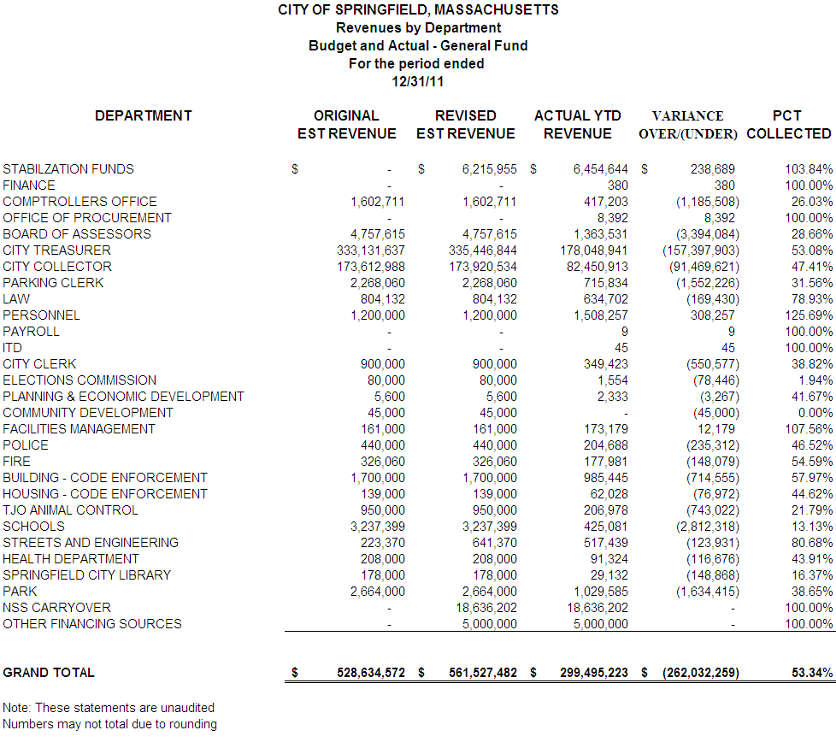
Section 4: Expenditures Highlights
The City of Springfield makes a one-time payment to the Retirement System in July of the fiscal year. The FY 12 payment was $24M

All School Teachers' salaries are expended between the months of September-June.

The Park Department runs many seasonal programs occurring in the warmer months of the fiscal year. The Park Department also operates two Municipal Golf Courses, Veterans and Franconia.

The Department of Public Works (DPW) experiences higher expenditures in the winter months due to the need for Snow and Ice Removal.

The City of Springfield offers Police Officers a yearly career incentive (Quinn Bill). The City made payment in November for $3.752M. This amount is partially subsided by the school department for the Springfield support unit.

The City of Springfield has established a Utility Revolving Fund. Department’s telephone and electric budgets are expended in the General Fund and moved to the Revolving Fund. This fund allows the City to pay telephone and electric bills in a central location.

The City of Springfield builds a lost time projection into the General Fund operating budget. The projected lost time in the FY 11 operating budget is $800K and this is found in the City Comptroller's budget.

The City of Springfield supplements the Trash Enterprise fund with a payment from the General Fund operating budget. This supplement is necessary to fully fund the City’s solid waste operation. In FY 12 this supplement was made in October.

$38.6M has been encumbered in the current budget by the City to cover obligations arising from purchase orders and contracts; that are chargeable to a department’s budget but not yet paid from a specific appropriation account.

The City expended $30.3M of the Long Term Debt budget in the month of September.

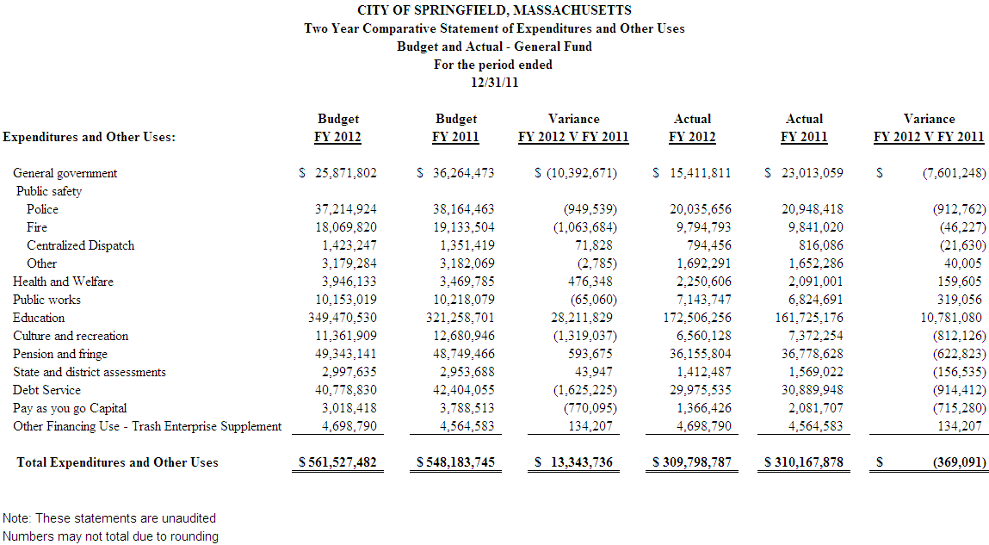

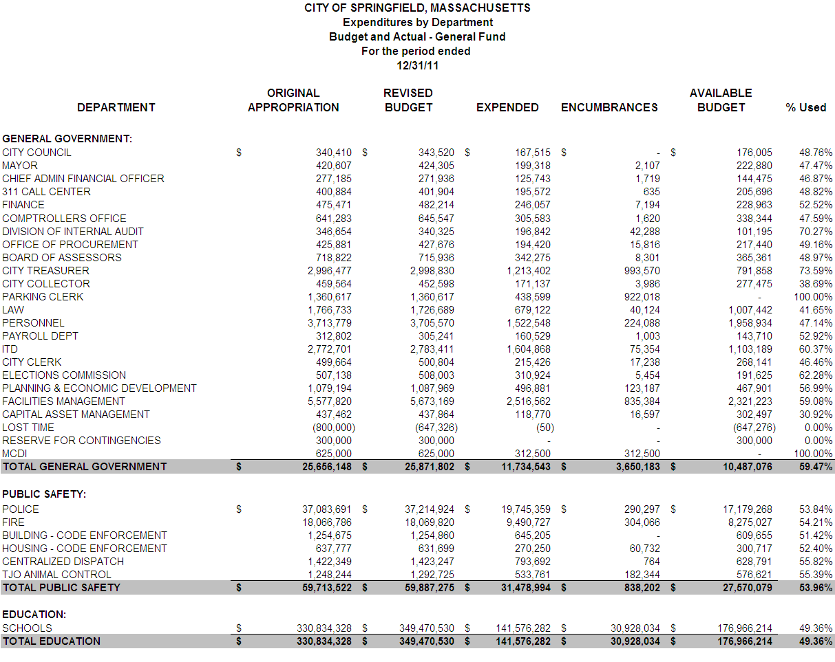
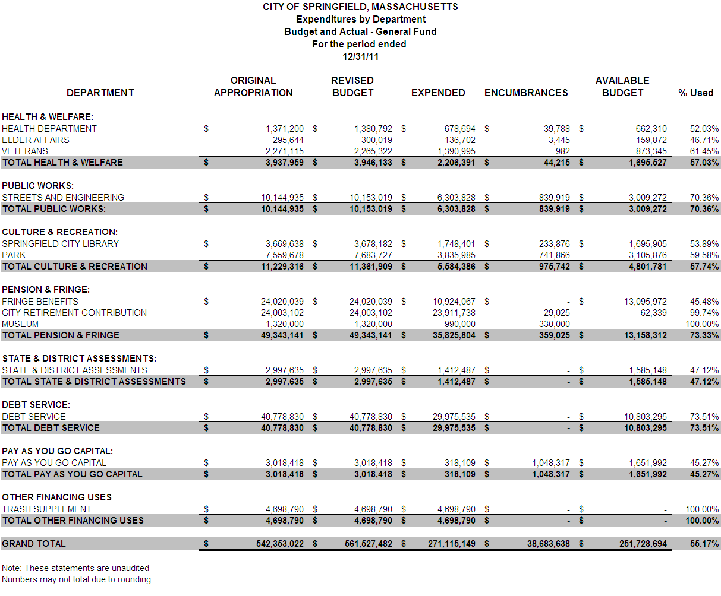

SECTION 5: GRANTS / GIFTS
The City of Springfield receives roughly $16.9 million in grant funding each year. This funding enhances programming and services throughout the City. Through the use of grants, Springfield is able to hire personnel, as well as procure professional services, supplies, and equipment that the general fund or taxpayers would otherwise be required to pay for or do without.

Grant Funds Accepted for this Financial Reporting Period: $2,918,980

City Department: Health
Grant Award: $1,194,003
Source: U.S. Department of Health and Human Services
Purpose: to provide healthcare and case management services to the homeless.

City Department: Health
Grant Award: $111,000
Source: MA Department of Health and Human Services
Purpose: to provide after-school career exploration programming for teenagers.

City Department: Health
Grant Award: $111,000
Source: MA Department of Health and Human Services
Purpose: to provide after-school career exploration programming for teenagers.

City Department: Health
Grant Award: $100,000
Source: MA Executive Office of Health & Human Services, Office of Refugees and Immigrants
Purpose: to enroll new refugees, asylees, entrants, secondary migrants, certified tracking victims, Visa holders, and other eligible participants into refugee benefit programs as applicable.

City Department: Health
Grant Award: $30,000
Source: MA Department of Health and Human Services
Purpose: to continue to support healthier eating and active living.

City Department: Health
Grant Award: $5,000
Source: New North Citizen’s Council
Purpose: to open for one evening gym site at Chestnut Middle School.

City Department: Health
Grant Award: $4,000
Source: Health Resources in Action
Purpose: to promote the ban of tobacco sales in pharmacies.

City Department: Planning & Economic Development
Grant Award: $200,000
Source: U.S. Environmental Protection Agency
Purpose: to address hazardous contamination materials at 55 Frank B. Murray Street.

City Department: Planning & Economic Development
Grant Award: $200,000
Source: U.S. Environmental Protection Agency
Purpose: to address petroleum contamination materials at E.S. Main Street.

City Department: Planning & Economic Development
Grant Award: $150,000
Source: MA Department of Housing & Community Development
Purpose: to be used towards the tornado rebuilding master plan and redevelopment strategy.

City Department: Park
Grant Award: $500,000
Source: MA Executive Office of Energy and Environmental Affairs
Purpose: to provide improvements to Hubbard Park.

City Department: Park
Grant Award: $15,000
Source: Health New England
Purpose: to provide evening gym programming.

City Department: Park
Grant Award: $35,000
Source: Health New England
Purpose: to provide evening gym programming.

City Department: Elder Affairs
Grant Award: $88,980
Source: Greater Springfield Senior Services
Purpose: to provide outreach, advocacy, information, and referral services to seniors.

City Department: Library
Grant Award: $10,000
Source: Massachusetts Cultural Council
Purpose: to provide cultural activities to local residents.

City Department: Dispatch
Grant Award: $164,997
Source: MA Executive Office of Safety & Security
Purpose: for training-related costs associated with the 9-1-1 system.

 | Quarter 2011 | Quarter 2012
Q1 | 3,026,944 | 3,126,354
Q2 | 2,488,853 | 2,918,980
Q3 | 2,614,439
Q4 | 8,561,336
TOTAL | 16,691,572

Section 6: Forecast
The forecast looks at the two major aspects of the annual operating budget:

- Revenue – The revenue forecast shows the FY09, FY10 and FY11 actual collections along with what was budgeted for FY12. In addition, it shows a projection for the FY12 year-end based on year to date collections and known collection cycles for the remainder of the fiscal year.
- Spending – The spending forecast shows the FY09, FY10 and FY11 actual spending by department along with what was budgeted for spending for FY12. In addition, it shows a projection for the FY12 year-end based on year to date spending and knowledge and trends of the department.
- The forecast is subject to change throughout the fiscal year and does not represent a definite surplus or deficiency.

Revenue Projection:
For the quarter ending 12/31/2011, the City’s revenue is relatively on track however there are some areas of exposure that we will continue to monitor. At this point, the report does not suggest solving for the potential exposure. If future reports still show a deficit, solutions will be suggested.

There are 3 areas of revenue that are trending below the budgeted amount for FY12:
- SPA Revenue – When building the budget for FY12, SPA indicated enhancements of revenue collections due to the ability to utilize the boot, license plate reader and towing. Because of delays in fully transferring the Chandler Street Lot along with locating bootable cars, revenues are coming in about $400K below estimates.
- TJO Revenue – When building the FY12 budget, the addition of communities was assumed that have not come on board to date. In addition, due to budget reductions, reduced hours have caused a decline in adoption revenues. Based on collections to date, revenues are estimated to come in $536K below budgeted.
- Cyr Arena Revenue – During FY12, we are not seeing the utilization of Cyr Arena as originally expected and therefore the revenues are not fully supporting the cost of its operations. Based on collections to date it is estimated that revenues will come in $212K below budgeted.

There is good news in revenue collections in that several revenues are exceeding budgeted figures, which helps to offset the impact of those that are not. These include our Medicare Part D revenue which has already been remitted to the City for $308K over the budgeted amount. In addition, Building permits are estimated to exceed the budgeted amount by $346K based on collections to date.

Below is a detailed accounting of revenue with watch items highlighted.
Spending Projection:
For the second quarter of FY12, there are several areas of spending exposure that will require the attention and action by Council. Some items are more time sensitive, therefore transfer orders will be submitted for the February meeting while other will continue to be watched as the fiscal year progresses.

Items requiring more timely attention include:
- Elections – Primary Costs – In developing the FY12 budget, the costs for the presidential primary that is to take place in February was not budgeted. The total cost is $81,360 of which $24,596 will be reimbursed by the State.
- Assessors – Professional Services – In developing the FY12 budget, the cost of the annual contract with Tyler was not appropriately budgeted as the contract crosses several fiscal years. In order to meet the needs of FY12, an additional $83,700 will be needed.
- Fire – Salaries – The FY12 budget for the Fire Department is experiencing an exposure of over $1,094,525 million that is driven by 3 main things: 1) The FY12 budget included a “vacancy savings” factor of $500K. As of December 31st, there were no vacant positions within the Fire Department therefore this target will likely not be met. 2) The Fy12 budget included a $400K reduction to Fire’s overtime that has not been achieved. 3) Unanticipated costs such as grievance settlements that have occurred during FY12. Resolving this deficit without supplemental funds would require immediate layoffs and station closings which the Mayor is not recommending.
- Veterans’ Benefits – The FY12 budget began to adjust for the increases in caseload that Veterans’ has been experiencing however continued caseload increases persist and are expected to grow by 100 cases by the end of the year. In addition, a new legal requirement of reimbursement for prescriptions and co-pays was not budgeted. Based on caseload to date it is estimated that an additional $500K will be needed. Seventy-five percent of eligible expenses are reimbursed next fiscal year.

These items will be brought to the City Council in the February meeting for transfers from FY11 Certified Free Cash as illustrated in the chart below.

Our goal is to have $40 million in stabilization reserves later this fiscal year. In addition to the time sensitive items above, there are additional spending areas that are being watched on a monthly basis. It is hoped that the projected deficits will not become real and / or surpluses in other areas of the budget will help to offset them. These items include:
- Law Settlements – $300K
- Treasurer Professional Services and Medicare Tax - $100K
- Information Technology Telephone Costs - $250K
- SPA Contingency Collection Fee - $200K

We will continue to monitor and manage these items as well as the entire budget in order to meet our goal. Below is a detailed chart of the FY12 budget highlighting the areas of exposure.

Does not include the Springfield Public Schools (SPS) which receives an estimated $68.6 in grant funding annually. The City’s Grants Director has written/submitted three grants for the SPS and continues to work with its staff when asked.

