
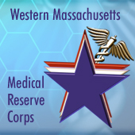

February 20, 2013

Dear MRC Volunteers, Partners, and Supporters:

This is the annual report for the past year and what a year it was!

We were asked by our Regional Coordinator, USDHHS Region I to increase our reporting capability from quarterly to monthly. We accepted this request as a challenge and as an opportunity to, first see if we could consistently comply and second to help us keep track of and appreciate all the great work you are doing each and everyday.

A highlight of our year, on the national level was having our very own Robert Klupa receive the National Volunteer Award for 2012 at the Integrated Training Summit in Nashville, TN. Bob served as our pharmacist at the October full-scale exercise. Thank you Robert for your generous and valuable contributions to our unit.

We are grateful to our MRC Leadership committee who have provided guidance, support and direction:
Deborah Graham
Keith Peters
Maria Elsie Sanchez
Mary Ann Marshman
Monica Stafford
Nick Karapasas
Robert Klupa
Robert Hackett
Rose Ann Gaskin-Rice
Jonathan Miller

Their areas of responsibility being:
Trainers: Robert Hackett
Maria Elsie Sanchez
Physician Recruitment: Nick Karapasas
Rose Ann Gaskin-Rice
Community Emergency Preparedness Training: Keith Peters

First Aid/CPR as Outreach for Community Events: Robert Hackett
Deborah Graham
Jennifer Tolpa
Individuals Requiring Additional Assistance (IRAA): Robert Klupa
Sustainability: ???

New Recruits during the year:
- Madelyn Allen (Maddie)
- William Baxter
- Jean Foggs
- Nick Karapasas
- Suzanne Piccione
- Magdalena Cuoco Rosado
- Sara Scagliarini
- Jennifer Tolpa
- Alaina Webster

Our sincere thanks to each of you for all that you do for the department and our city.

Sincerely,

Bettye Anderson Frederic
Deputy Director/ MRC Coordinator

Shenell Ford
Advocate

MRC Activities 2012

Start Date | Activity | Action
1/11/2012 | Springfield MMRS meeting | •
1/11/2012 | Hampden County MRC Advisory Group Meeting | •
1/13/2012 | CPR for volunteers | •
1/23/2012 | CPR for volunteers | •
1/23/2012 | CPR for volunteers | •
1/24/2012 | Quarterly Unit Meeting | •
2/3/2012 | Let's Move and Million Hearts Campaigns | •
2/8/2012 | MRC Tabletop Exercise - Tornado | •
2/9/2012 | MRC-101 Training | •
2/16/2012 | Springfield MRC Leadership Meeting | •
2/17/2012 | Department, other MRC Units, surrounding Hospitals and many more, Multiple topic were dicussed where the communities in Hampden County could better prepare themselves for the next emergency | •
3/8/2012 | MRC Information Session for Western New England University 2 members of the Springfield Department of Health andServices MRC Unit attened an Emergency Summit for Hampden County | •
3/27/2012 | Western Mass Spring Leadership Workshop | •
4/14/2012 | The Springfield DHHS attended the H.E.L.P. Expo in Springfield, MA on April 14th. | •
4/20/2012 | Functional Exercise-Mass Dispensin Site | •
5/4/2012 | Commission Regional Dialogue | •
5/4/2012 | Commission Regional Dialogue | •
5/5/2012 | Super-Training Saturday- Psychological First Aid MRC-101, ICS 100 NIMS-700 | •
5/5/2012 | Super-Training Saturday- Psychological First Aid MRC-101, ICS 100 NIMS-700 | •
5/15/2012 | EDS Comm Subcomm | •
5/16/2012 | Springfield MRC Leadership Meeting | •
5/21/2012 | MRC ITS Training | •
5/22/2012 | National Integrated Summit | •
6/1/2012 | Emergency preparedness outreach and demonstration | •
6/2/2012 | Training for new volunteers | •
6/6/2012 | CPR Training | •
6/19/2012 | Technical Assessment Call | •
6/20/2012 | Overall program goals | •
7/11/2012 | Advisory Committee Meeting | •
7/12/2012 | Planning Meeting | •
8/3/2012 | Planning for EDS exercise | •
8/6/2012 | Planning EDS exercise | •
8/10/2012 | WMMRC orientation | •
8/10/2012 | Planning for EDS exercise | •
8/13/201 | MRC/Sheltering Conference call | •
8/15/2012 | Planning for EDS exercise | •
8/20/2012 | Planning EDS exercise | •
8/21/2012 | MRC Orientation | •
8/21/2012 | Planning Big E event | •
8/22/2012 | contact with community college | •
8/27/2012 | conference with MRC adjunct staff | •
8/28/2012 | MRC/Sheltering Conference call | •
8/29/2012 | Planning for EDS exercise | •
9/5/2012 | NACCHO Grant Materials | •
9/6/2012 | Proclamation Day on the steps of City Hall | •
9/7/2012 | Interview for MRC interns | •
9/12/2012 | Meeting with AIC Dean | •
9/12/2012 | EP training for MRC | •
9/13/2012 | MRC 2nd Intern internview | •
9/13/2012 | Agawam BOD/Big E meeting | •
9/14/2012 | Get Ready/MRC outreach planning | •
9/18/2012 | Get Ready - Tower Square | •
9/19/2012 | MRC Leadership meeting | •
9/21/2012 | Let' s Make a Plan training | •
9/22/2012 | Gardner Memorial Church Outreach | •
9/24/2012 | Big E Outreach | •
9/25/2012 | MRC quarterly meeting | •
9/26/2012 | meeting with new intern | •
9/28/2012 | Veteran Standown | •
9/30/2012 | Suicide Prevention Walk at the Mass Mutual Center | •
9/30/2012 | "Out of the Darkness" Suicide Prevention Walk | •
10/3/2012 | Flu Clinic at Mayflower Senior Center | •
10/9/2012 | Intern Orientation | •
10/10/2012 | MRC Advisory | •
10/12/2012 | Sheltering Workshop | •
10/16/2012 | Administrative Advocate | •
10/17/2012 | Flu Clinic | •
10/19/2012 | New Leadership Charter School School Health & Safety Fair | •
10/19/2012 | Strategic National Stockpile Delivery | •
10/20/2012 | Full-scale exercise | •
10/21/2012 | Distant Storm - Full Scake Patient Reception Team Exercise National Disaster Medical System | •
10/22/2012 | Flu Clinic | •
10/24/2012 | Internet Conference | •
10/25/2012 | Presentation to Mayflower Senior Center residents | •
11/1/2012 | Regional Coalition meeting | •
11/3/2012 | Train A Thon | •
11/7/2012 | New Volunteer Badging/Certification | •
11/14/2012 | MRC Regional Advisory Meeting | •
11/18/2012 | Staten Island Sandy Recovery Assessment | •
11/27/2012 | MRC State Meeting | •
11/28/2012 | MRC Interns Video- Unnatural Causes | •
11/29/2012 | MRC advocate One on One | •
11/30/2012 | Intfectious diseases and sheltering exercise | •
12/5/2012 | NAACHO Leadership Training Summit | •
12/10/2012 | Staff meeting | •
12/19/2012 | Staff meeting with Advocate | •
12/19/2012 | MRC Leadership meeting | •

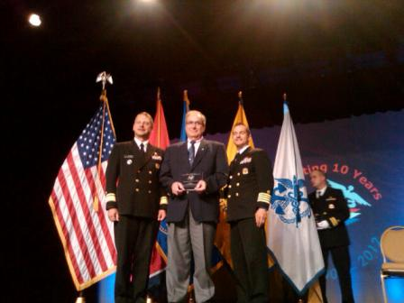

Robert Klupa, National Volunteer Recipient Awardee 2012

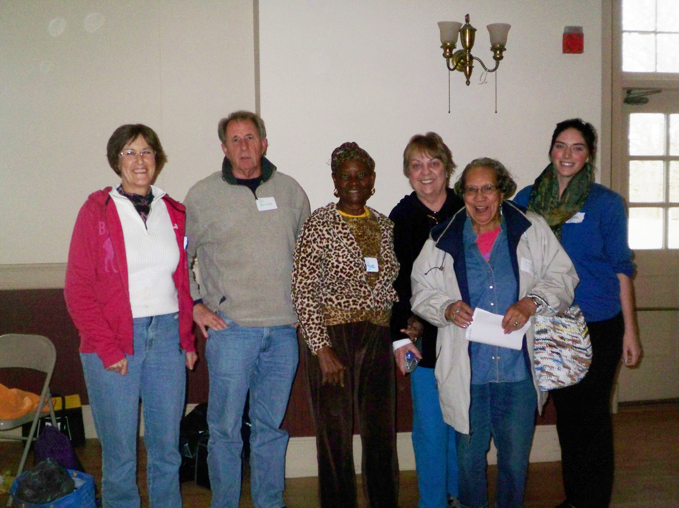

New recruits:

Nick Karapasas – No picture available

Suzanne Piccione – No picture available

Magdalena Cuoco Rosado – No picture available

Sarah Scagliarini – No picture available

Jennifer Tolpa – No picture available

